**PROJECT TITLE**

**College Name:**Rathinam college of liberal arts and science @tips global institiute

**College Code:** CD

**TEAM ID:** NM2025TMID27703

**TEAM MEMBERS:** 4

**Team Leader Name:**ROSHINI S

**Email:**roshini.aid23t@rathinam.in

**Team Member1:**Janani L

**Email:**janani.bca23t@rathinam.in

**Team Member:**Mohith T K

**Email:**mohith.aid23t@rathinam.in

**Team Member:**Akash S

**Email:**akash.aid23t@rathinam.in

1. **INTRODUCTION:**

Project Overview :

This project is a comprehensive Salesforce application to streamline and manage various operational aspects of medical inventory. The system aims to efficiently maintain supplier details, manage purchase orders, track product details and transactions, and monitor the expiry dates of products. Maintain detailed records of suppliers, including contact information. Catalog product information, including descriptions, stock levels. Monitor and track product expiry dates to avoid using expired items. Comprehensive reports to track supplier performance, and purchase orders.

**OVER VIEW ABOUT THE PROJECT**

|  |  |  |  |
| --- | --- | --- | --- |
| **PHASE: NO** | **MILESTONE NAME** | **DESCRIPTION** | **PAGE NO** |
| **1** | **Salesforce Account** | Creating developer account and Account activation | **1-2** |
| **2** | **Objects** | Creating object for product, purchase order,order item,inventory transaction and supplier in the object manager | **2-3** |
| **3** | **Tab’s** | Creating tabs for all the created objects | **4-5** |
| **4** | **The Lightning App** | Creating a lightning app for medical inventory management | **6** |
| **5** | **Fields** | Creating fields for all the created objects | **7-18** |
| **6** | **Editing of page layouts** | Editing page layouts for product object,purchase order,order item,inventory transaction,and supplier object. | **18-22** |
| **7** | **Compact layouts** | Creating a compact layouts for product objects,and purchase order object. | **22-23** |
| **8** | **Validation rules** | Creating a expected delivery date validation rule for empoyeemobject | **24** |
| **9** | **Profiles** | Creating an profile for inventory manager,and purchase manager | **24-27** |
| **10** | **Roles** | Creating roles for purchasing manager | **27-28** |
| **12** | **Permission set** | Creating an permission set | **28-30** |
| **13** | **Flows** | Creating flow to update the actual delivery date | **30-32** |
| **14** | **Triggers** | Creating an trigger to calculate the total amount on order item | **33-35** |
| **15** | **Reports** | Creating an report for purchase orders based on suppliers (summary),creating an complete purchase details | **36-38** |
| **16** | **Dashboards** | Creating an dashboard for medical inventory management and viewing the dashboard | **38-39** |

|  |
| --- |
|  |

### **Milestone 1-Salesforce Account**

DEVELOPMENT PHASE: **Activity 1: Creating Developer Account**

By using this URL-<https://developer.salesforce.com/signup>

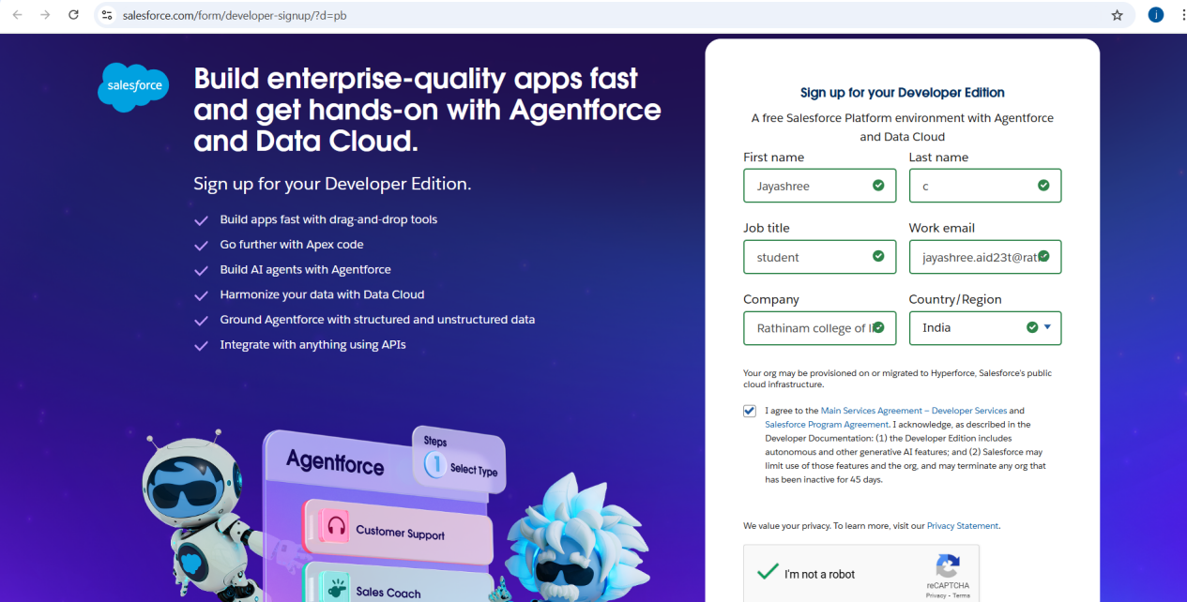

### **Activity 2: Account Activation**

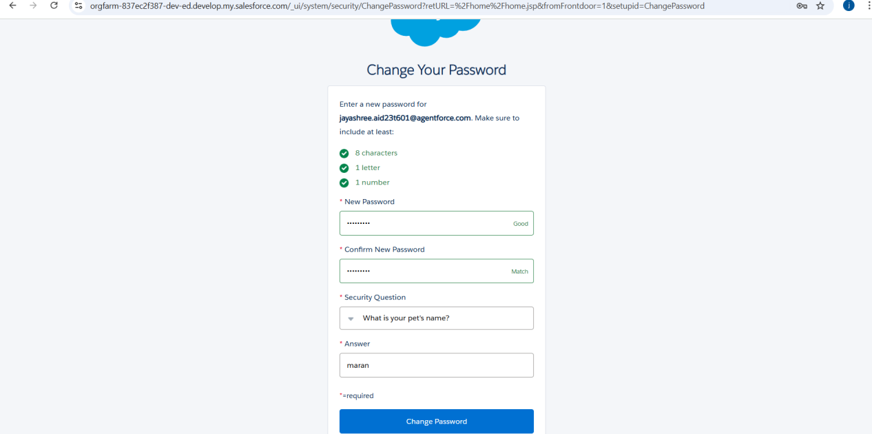

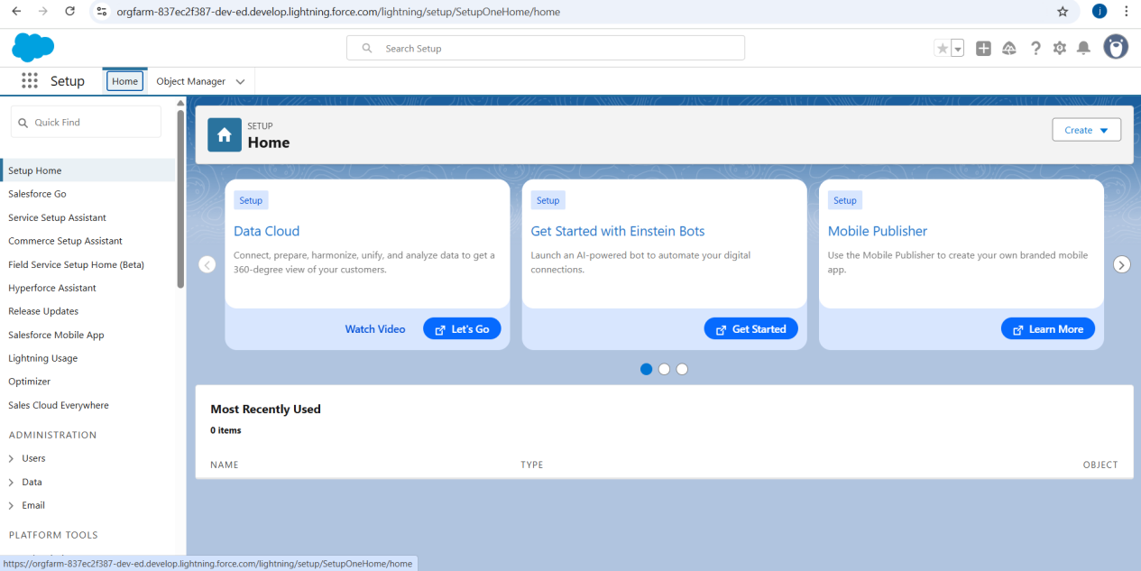**Milestone 2- Objects**

**Activity 1: Creating a Product Object**

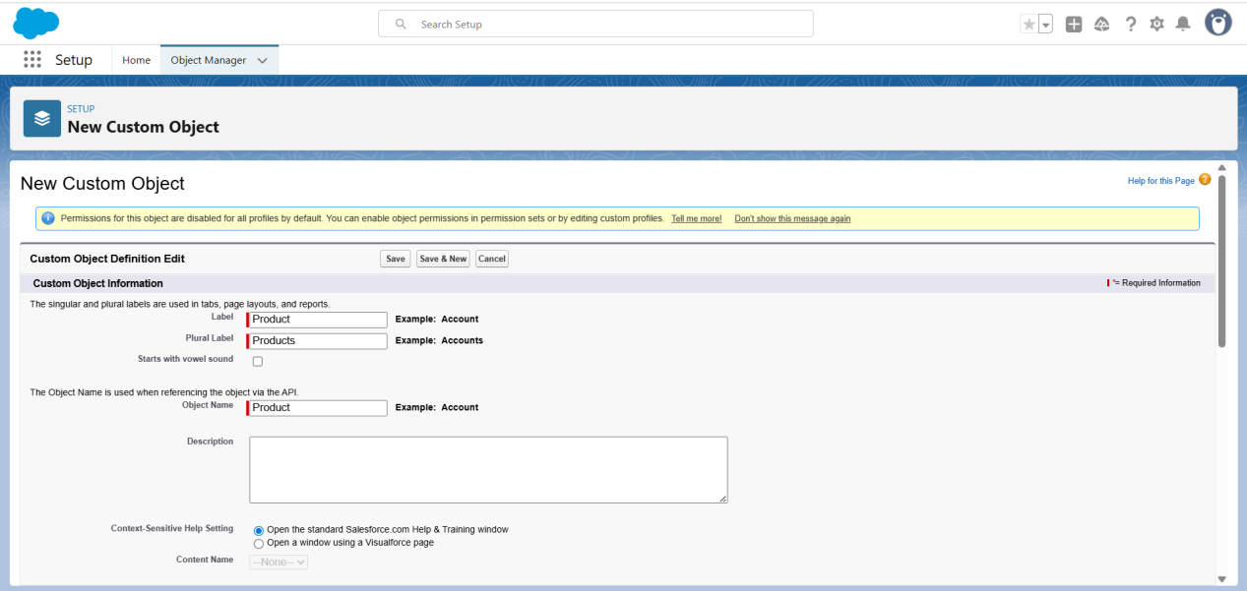

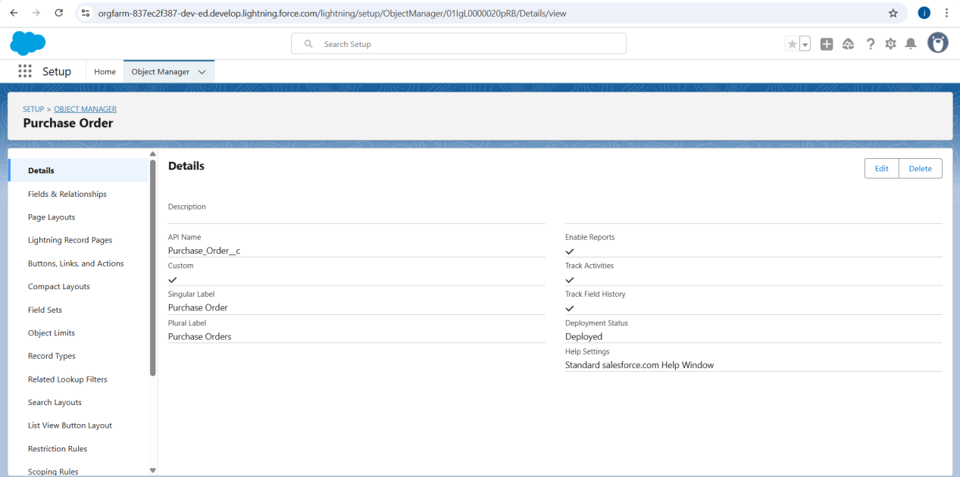

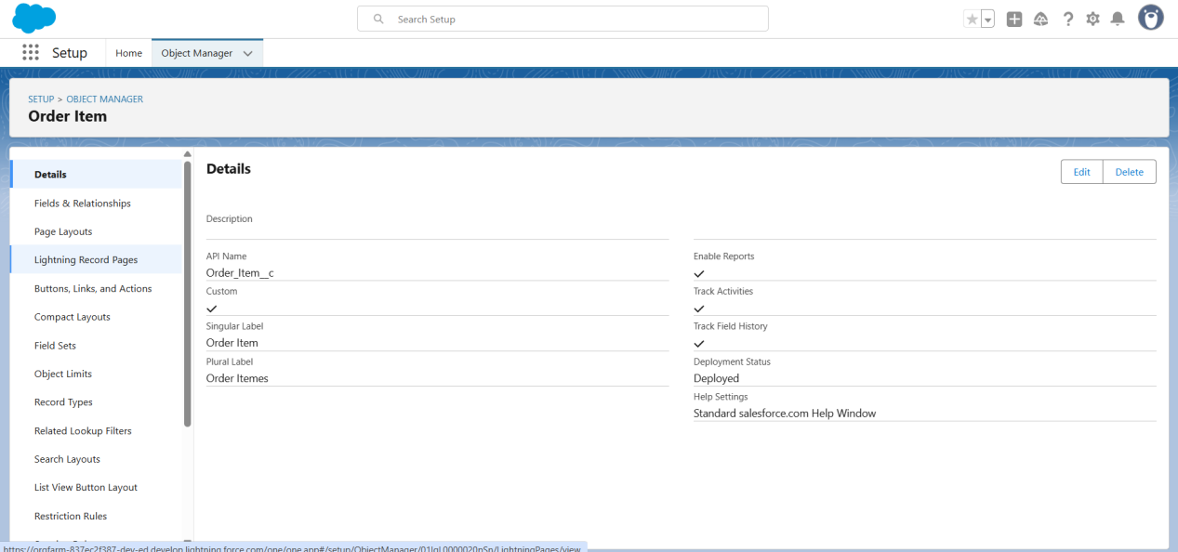

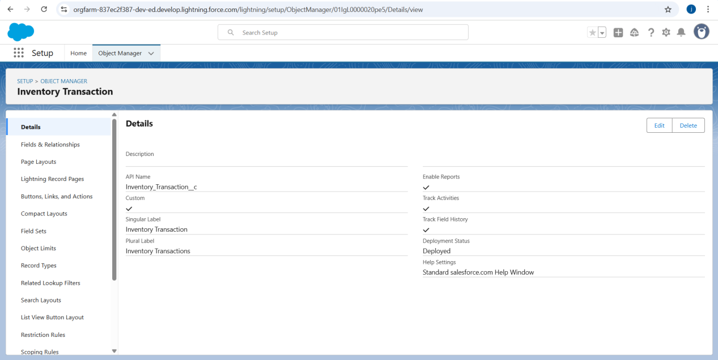

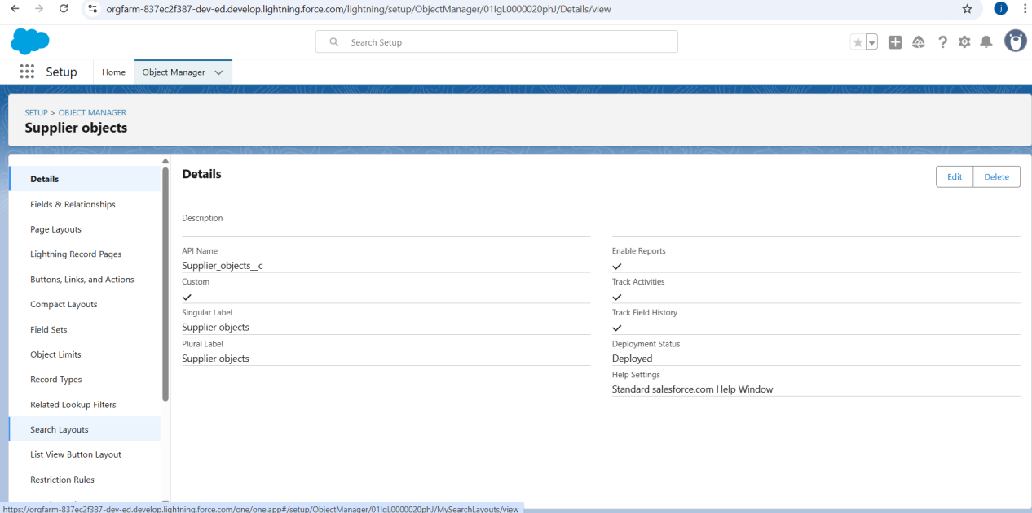

### **Milestone 3- Tabs**

### **Activity 1: Creating a tab for Product Object**

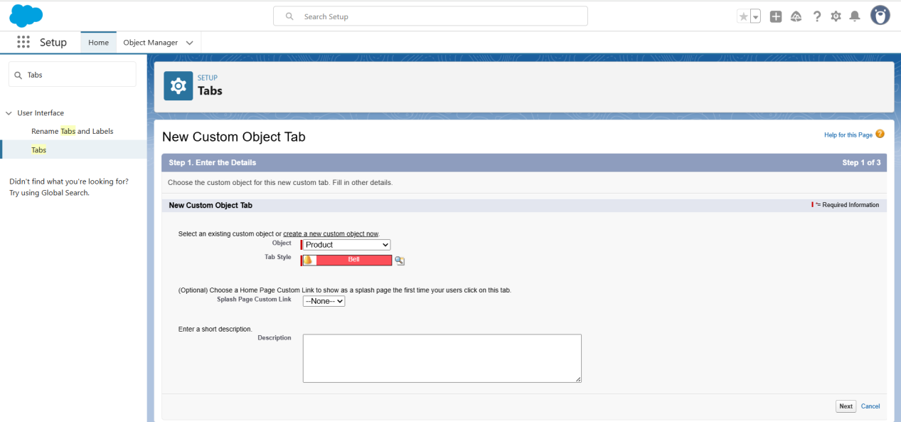

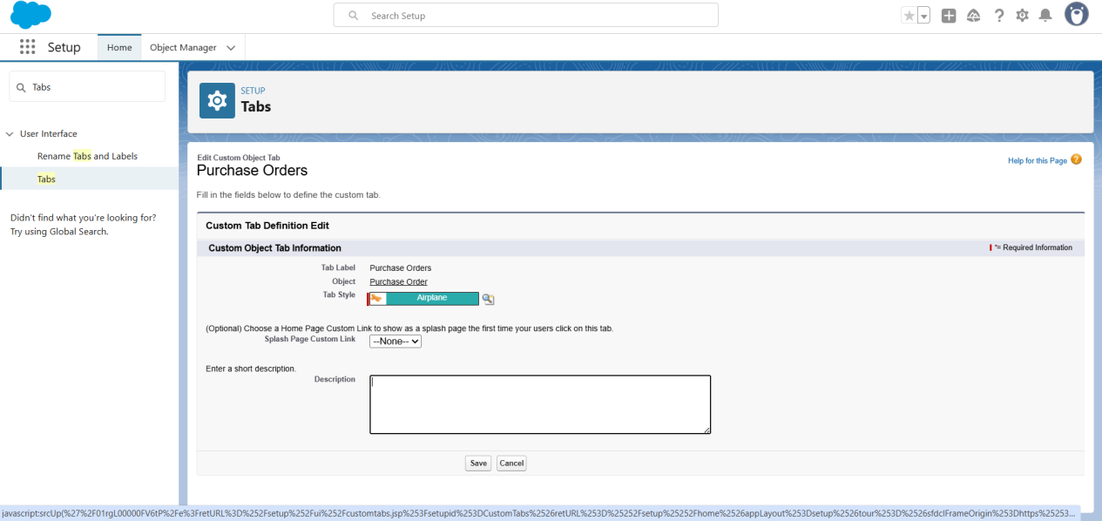

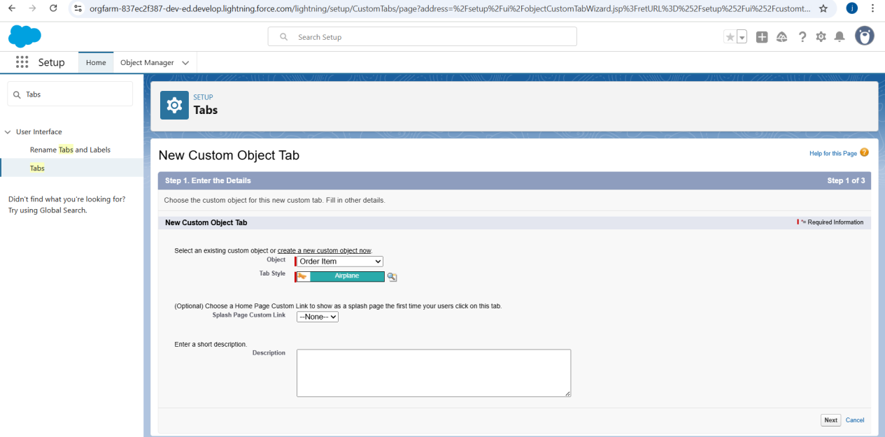

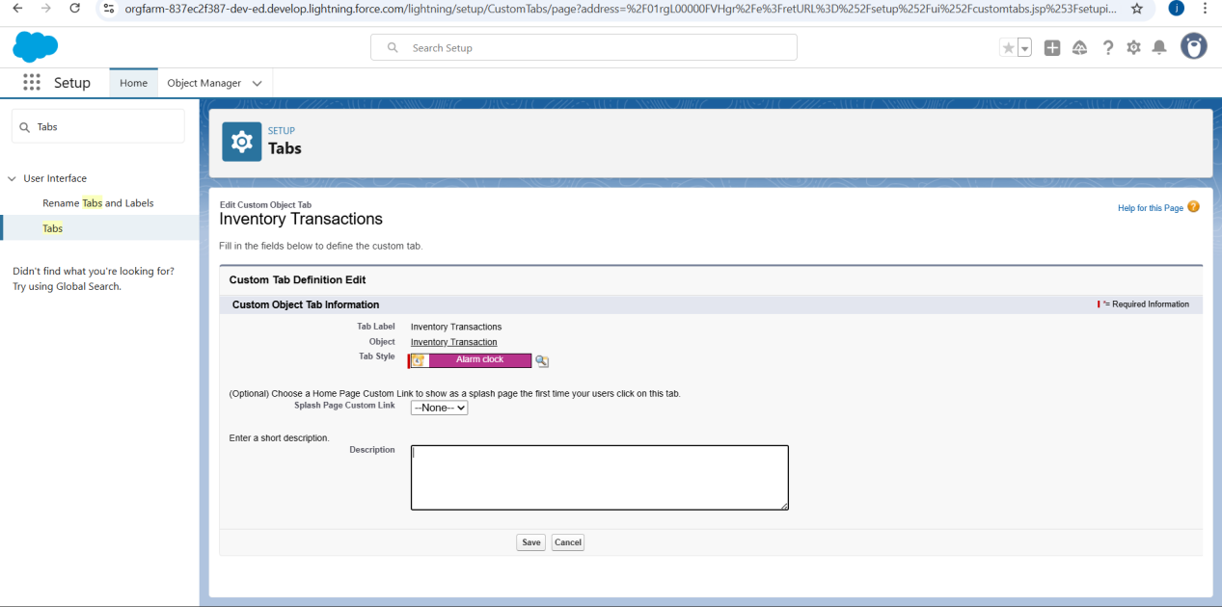

### 

### **Milestone 4- The Lightning App**

### **Activity 1: Create a Lightning App for Medical Inventory Management**

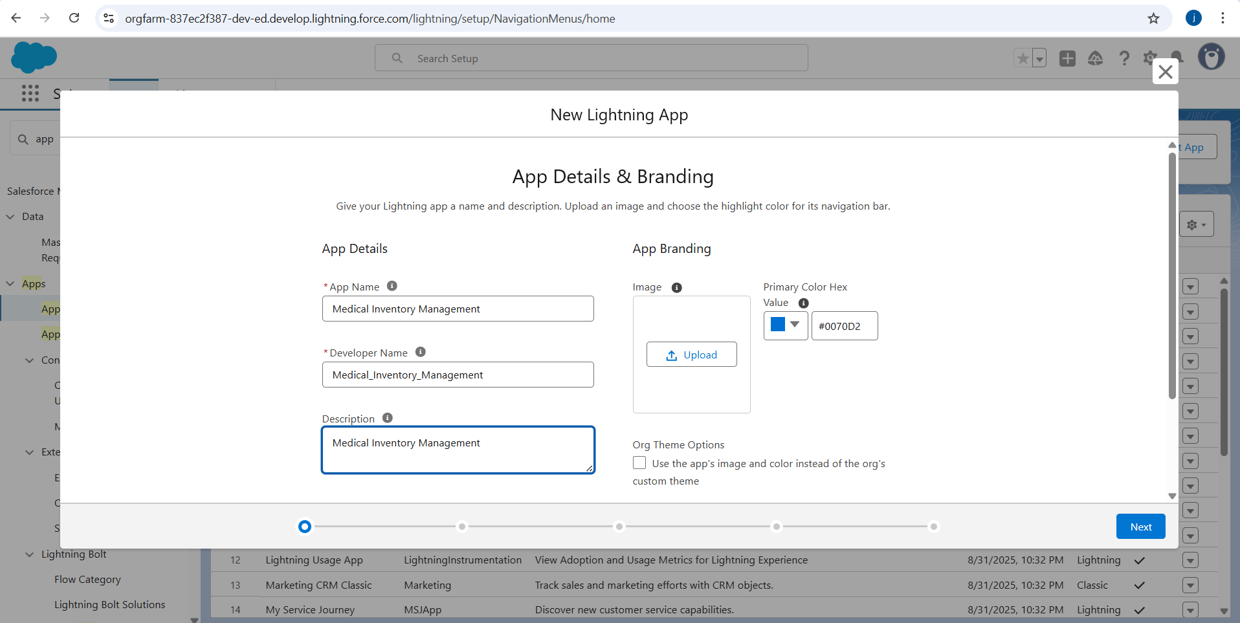

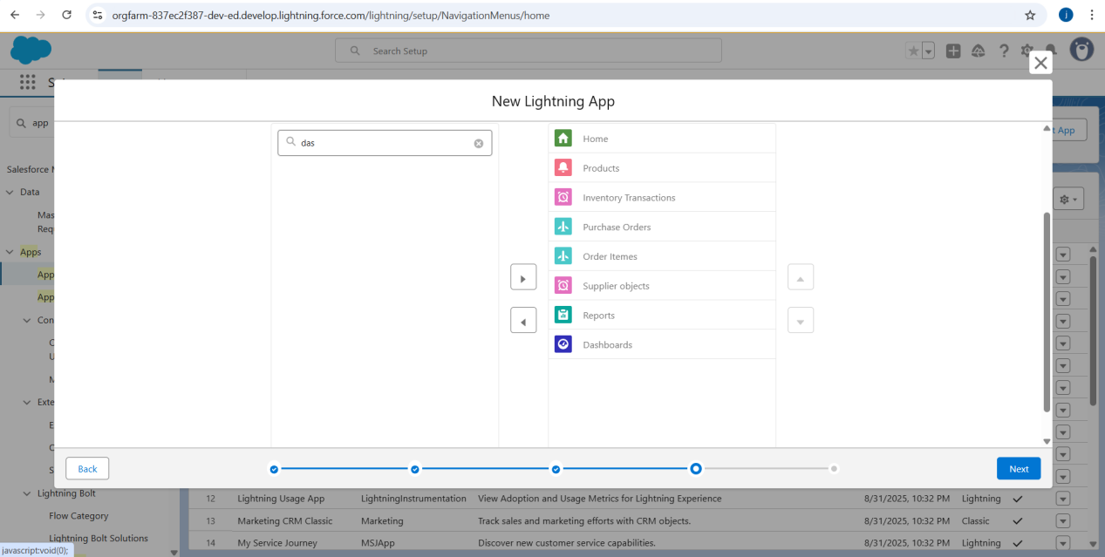

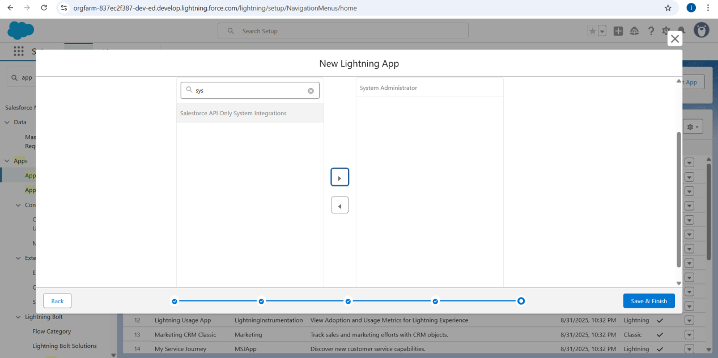

**Milestone 5- Fields**

### 1.**Creating a Text Field in Product Object**

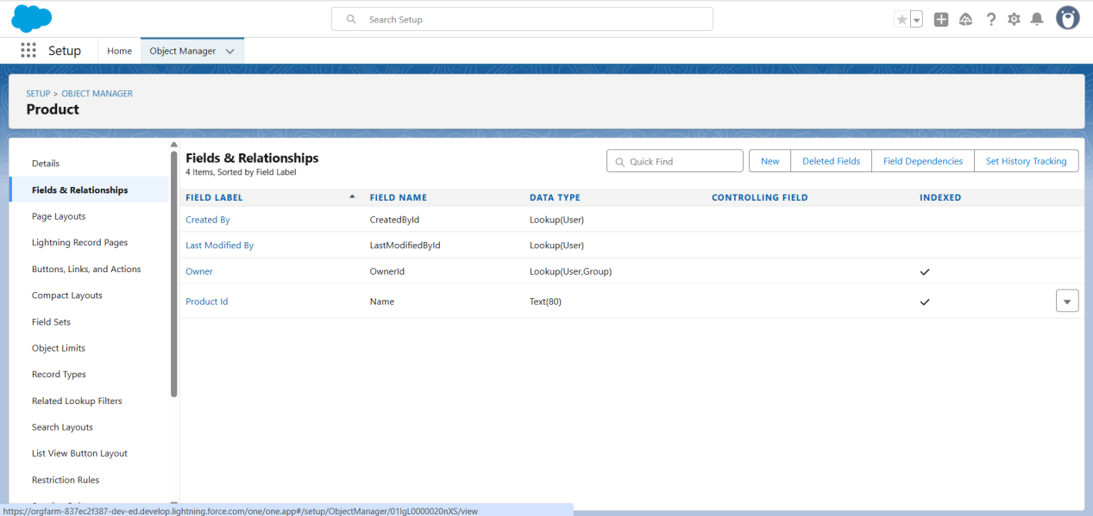

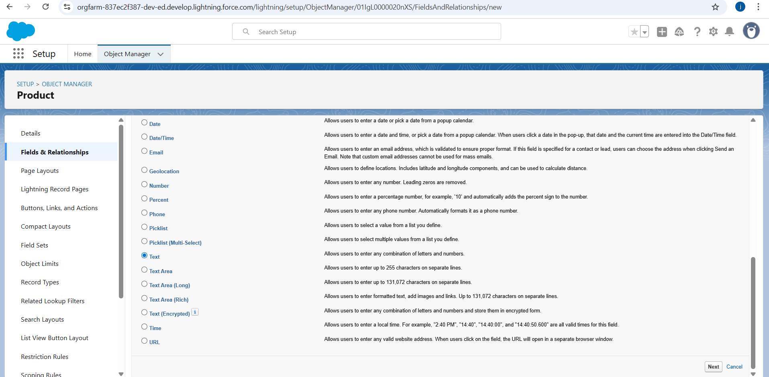

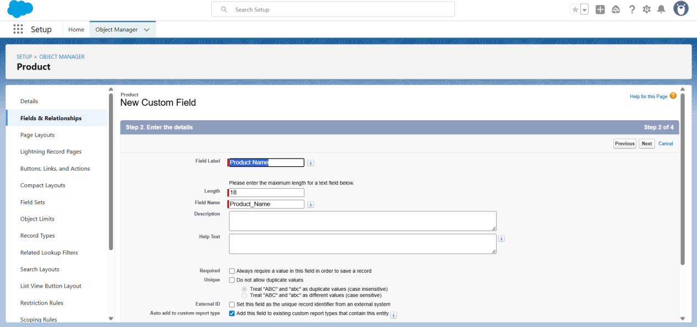

### **Creating a TextArea Field in Product Object**

### 

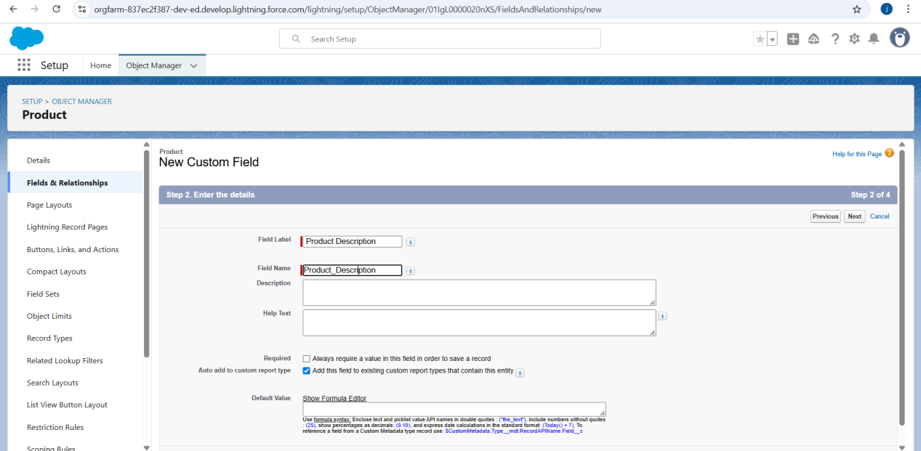

### **Creating a Number Field in Product object**

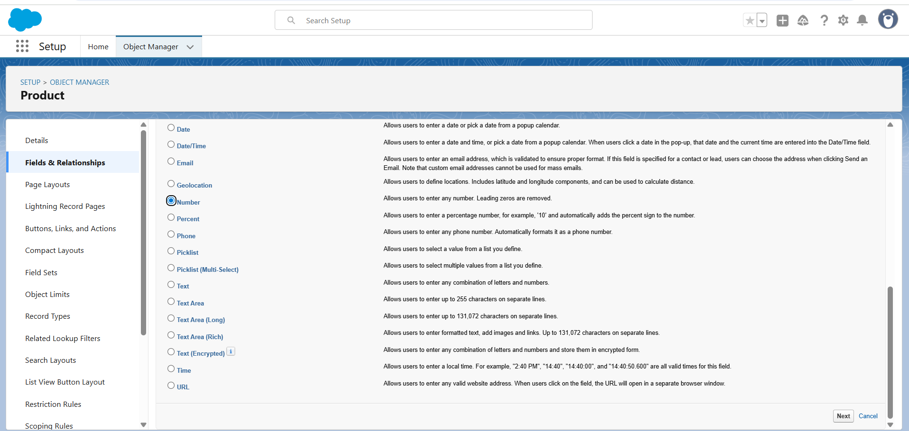

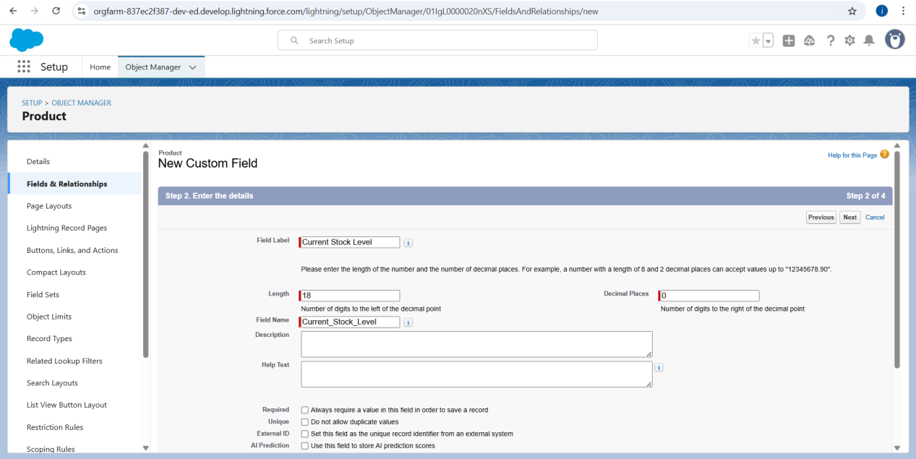

### **Creating a Currency Field in Product object**

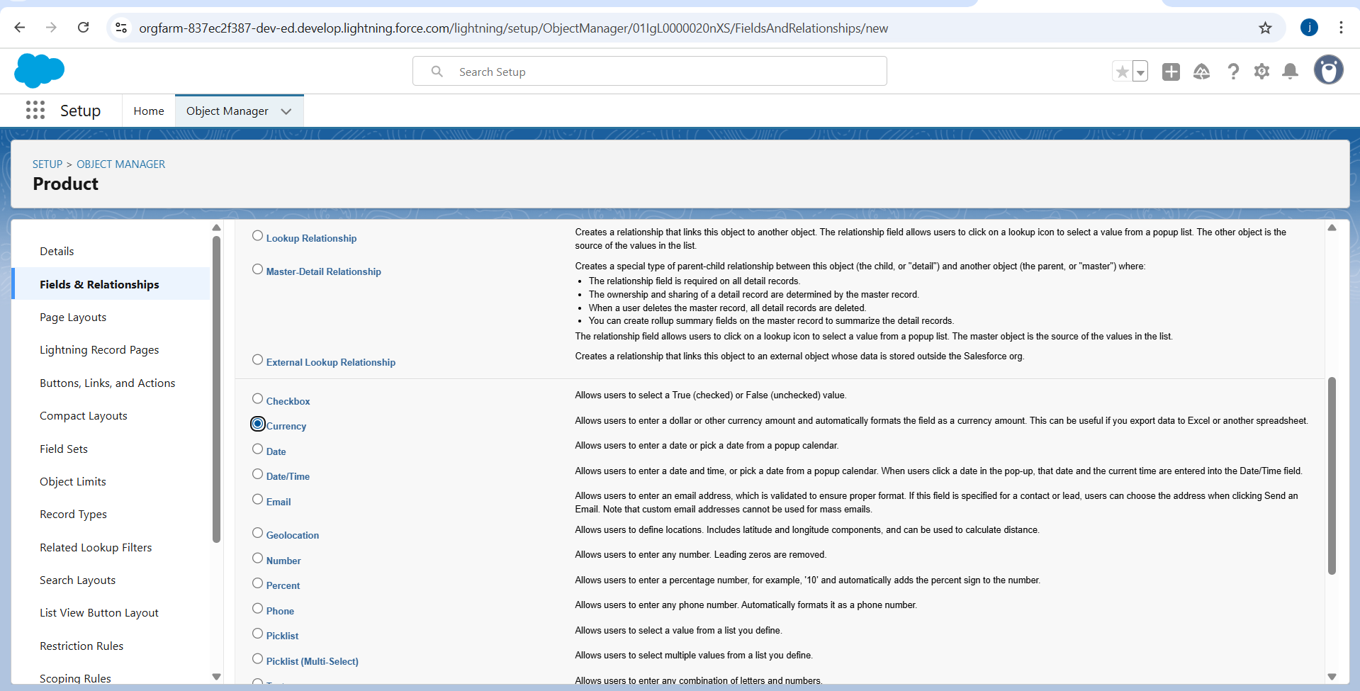

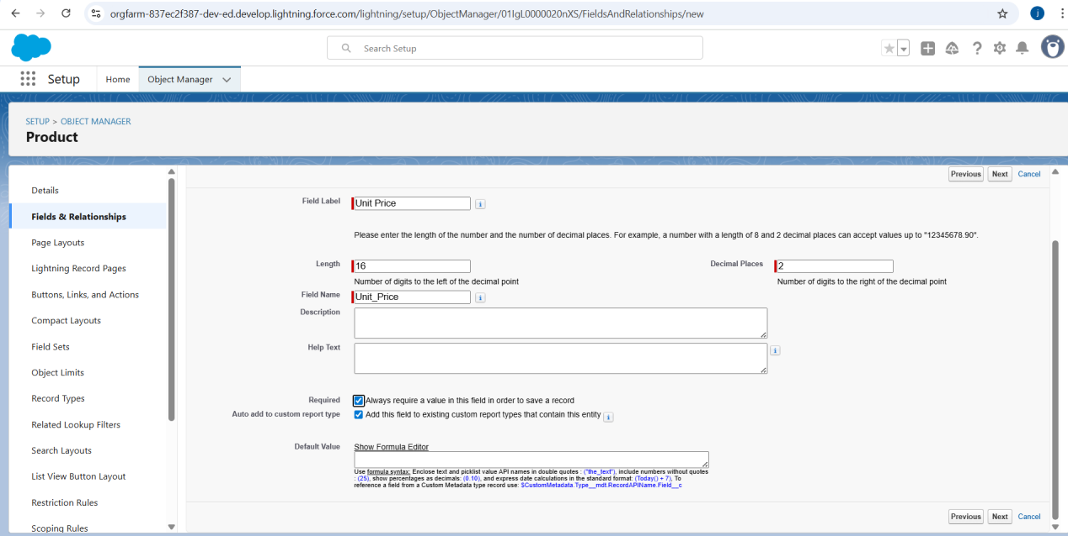

### **Creating Lookup Relationship in Purchase Order Object**

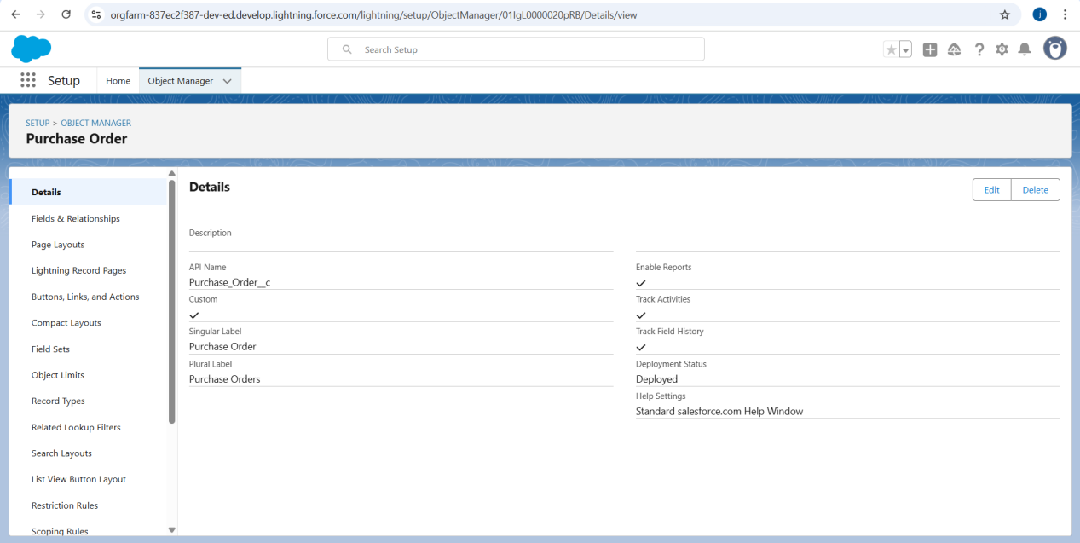

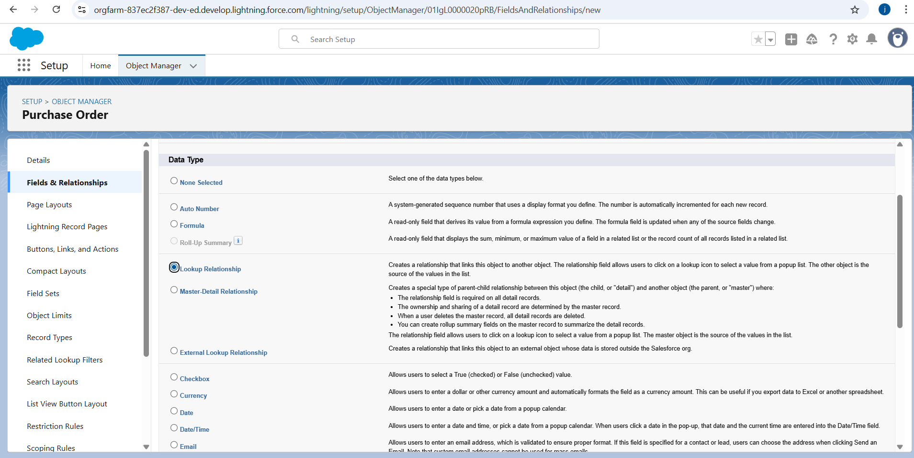

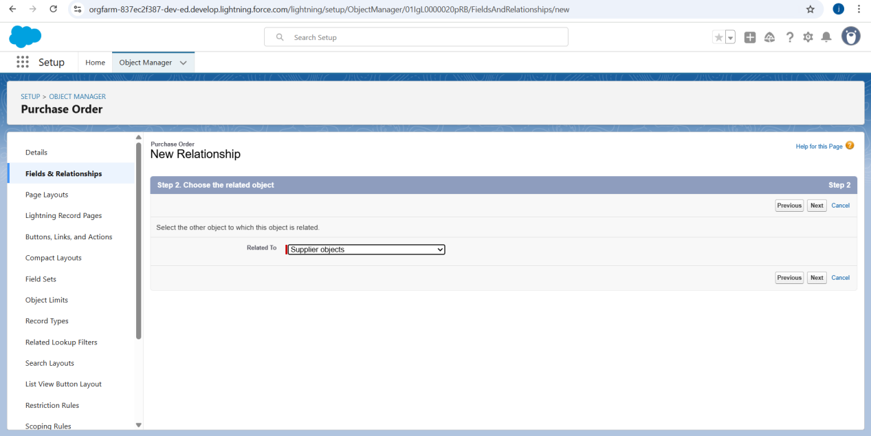

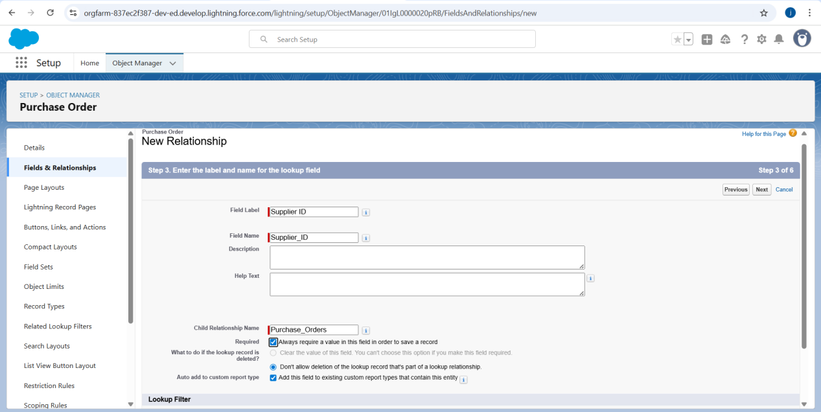

### **Creating a Date Field in Purchase Order object**

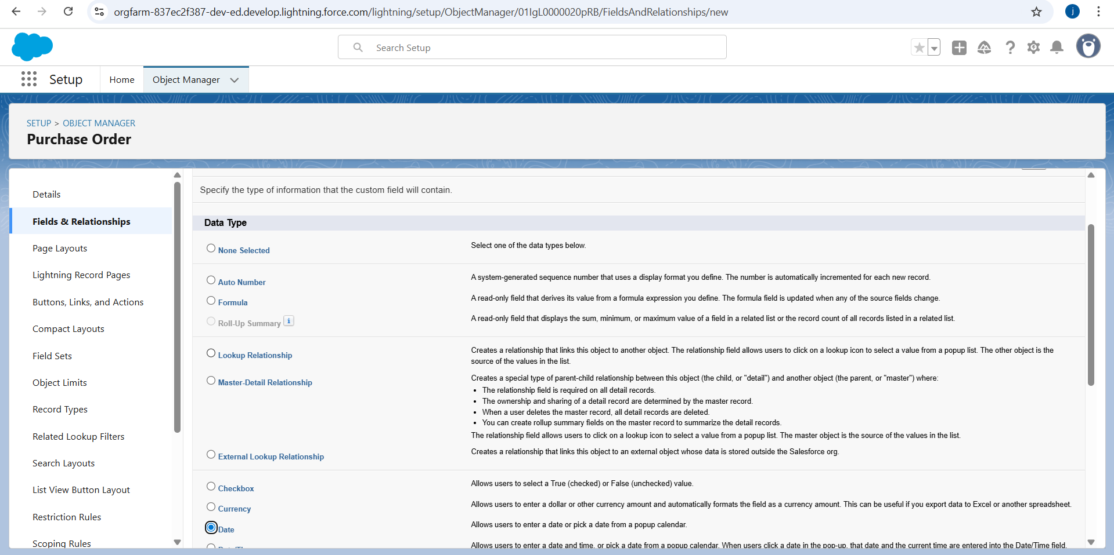

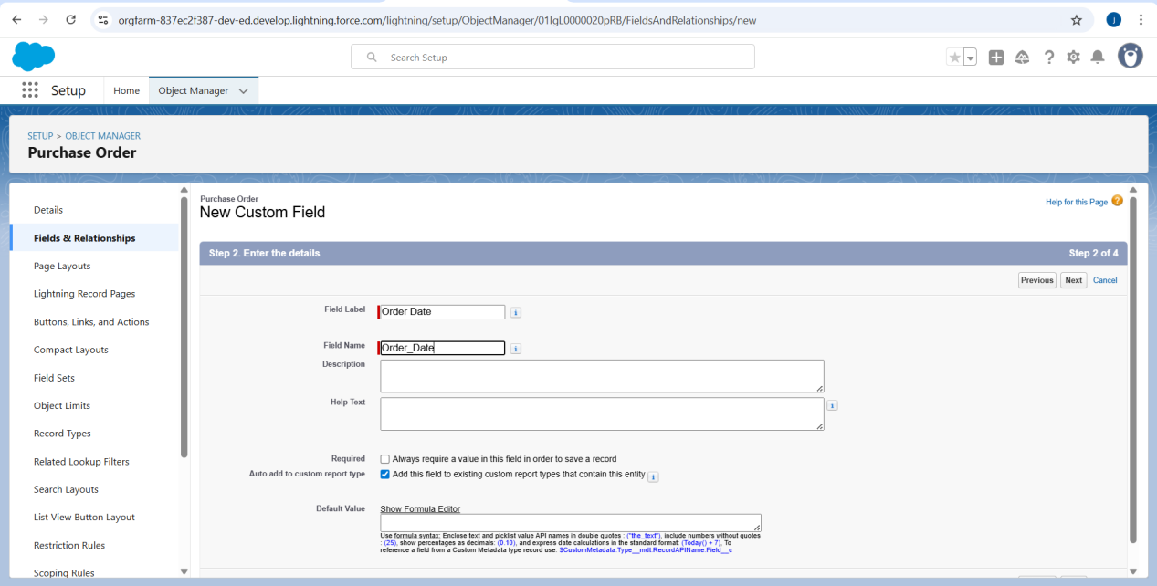

### **7.Creating a Roll-Up Summary Field in Purchase Order object**

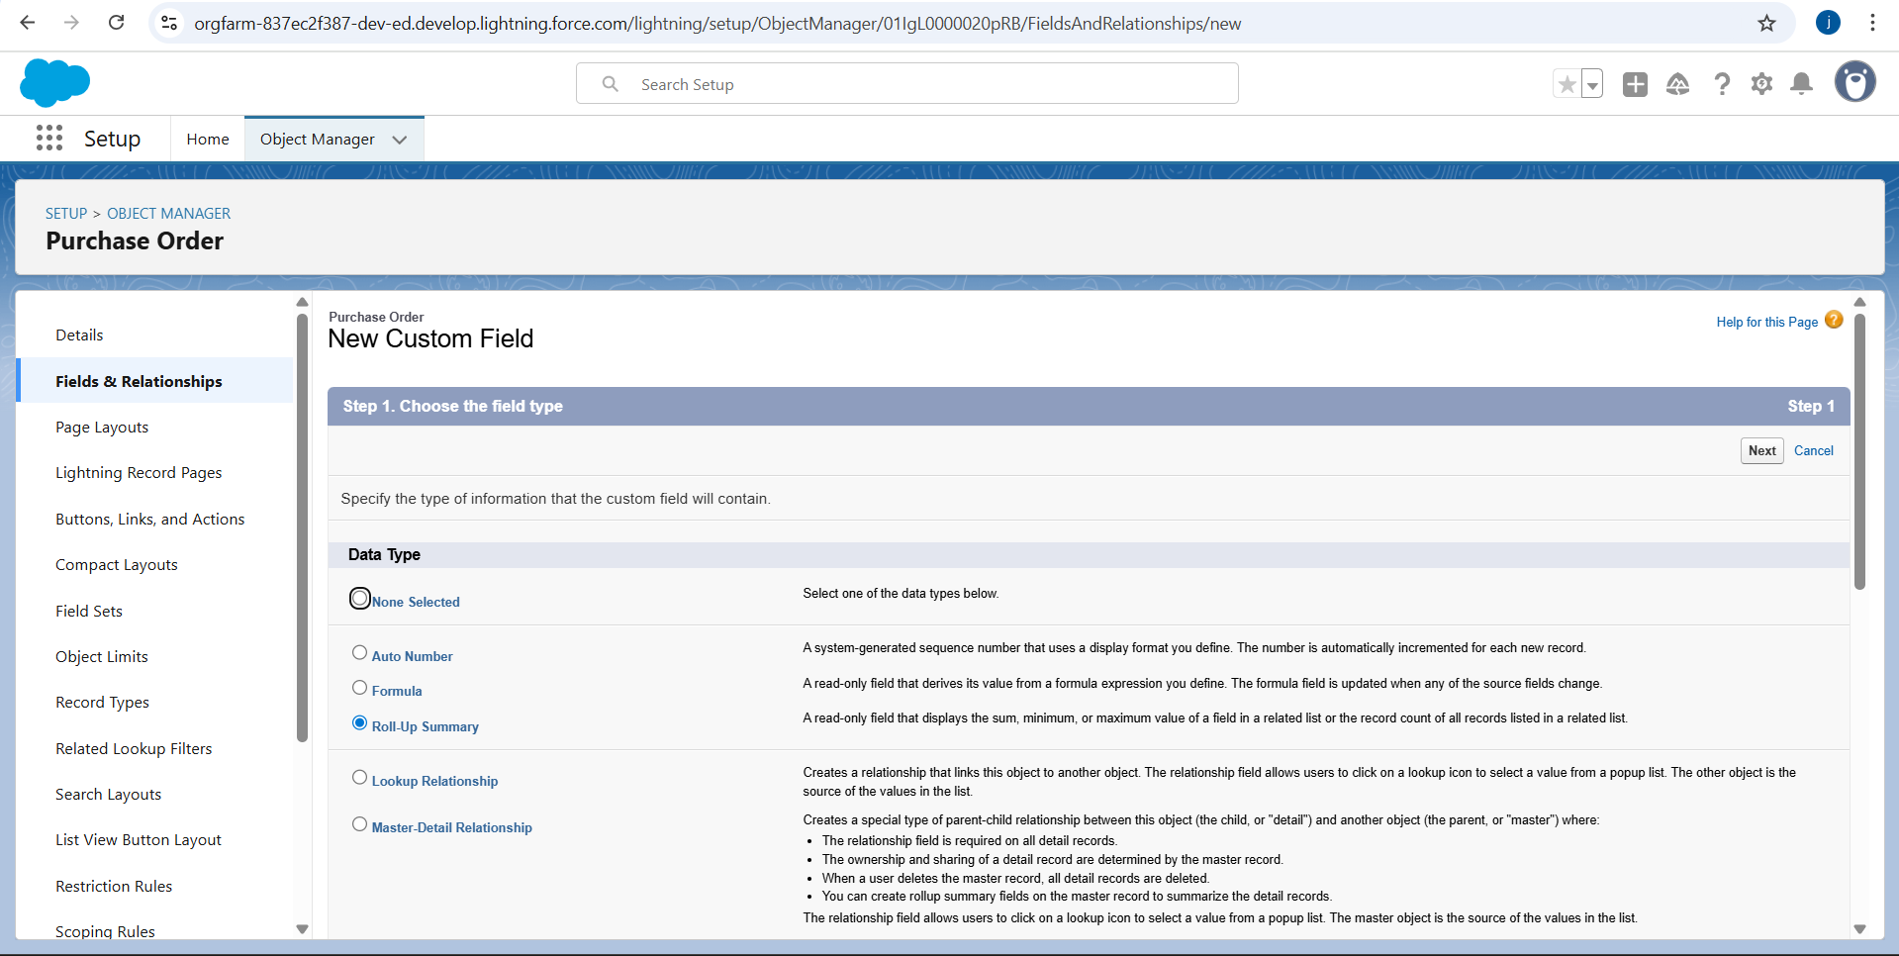

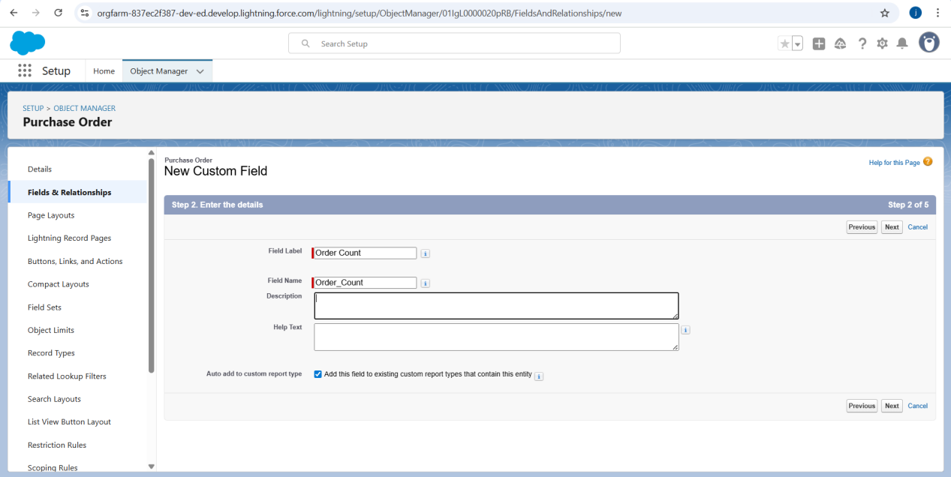

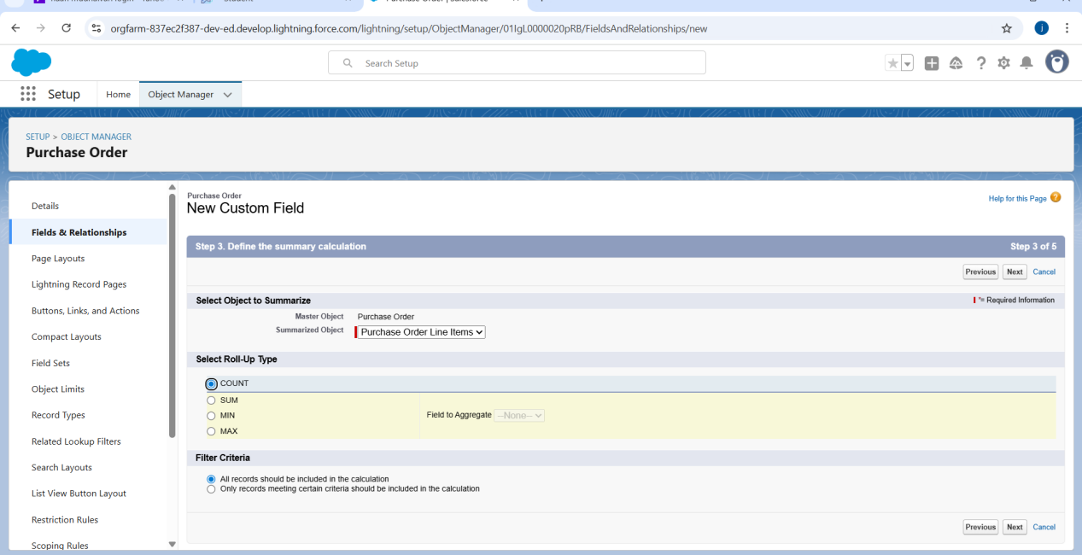

### **8.Creating a Unit Price Formula Field in Order Item object**

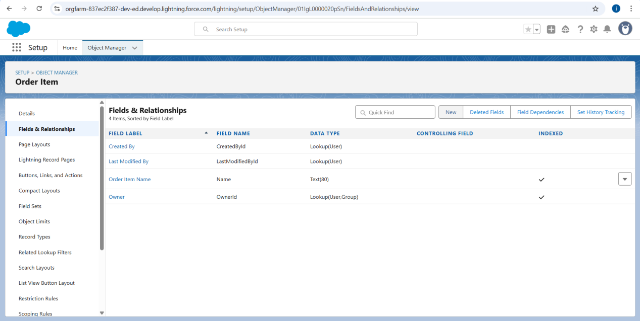

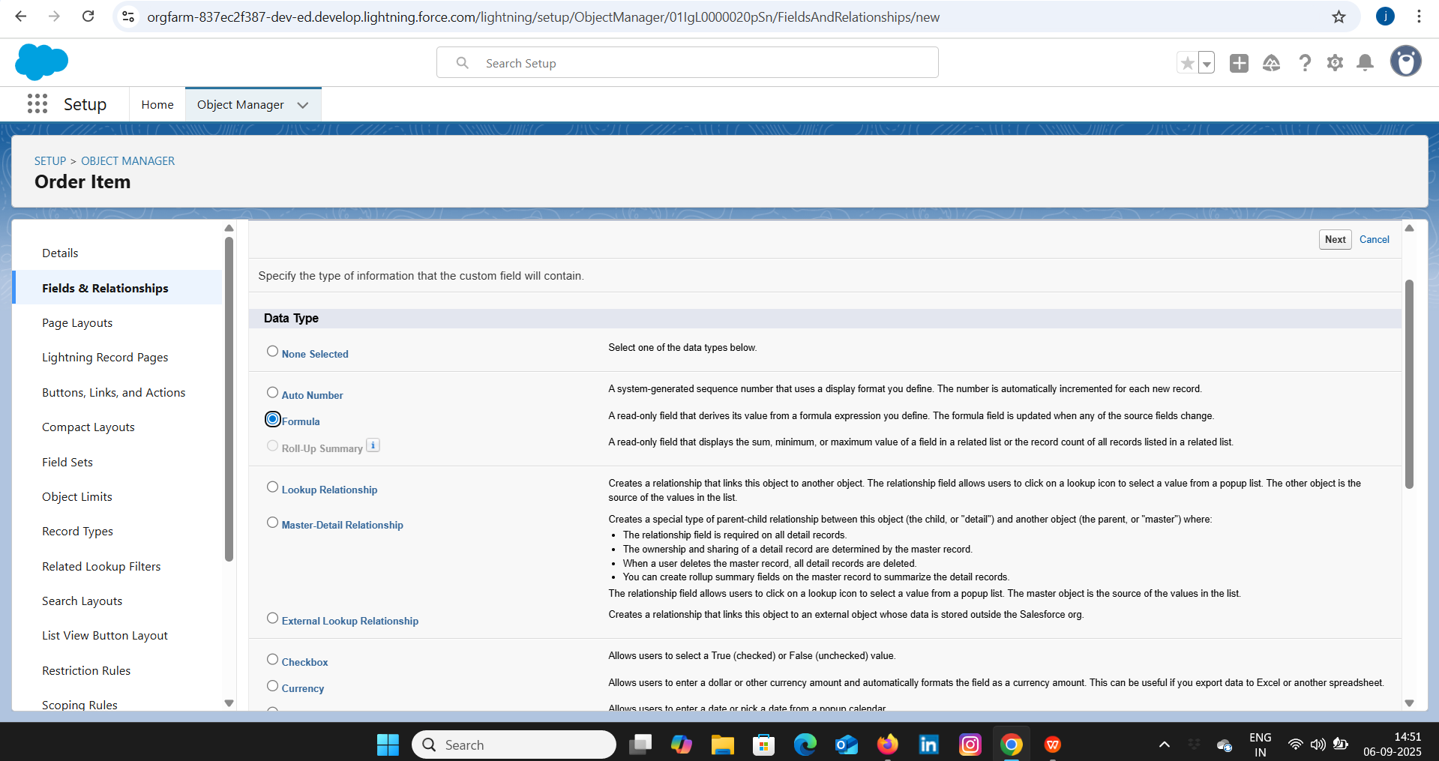

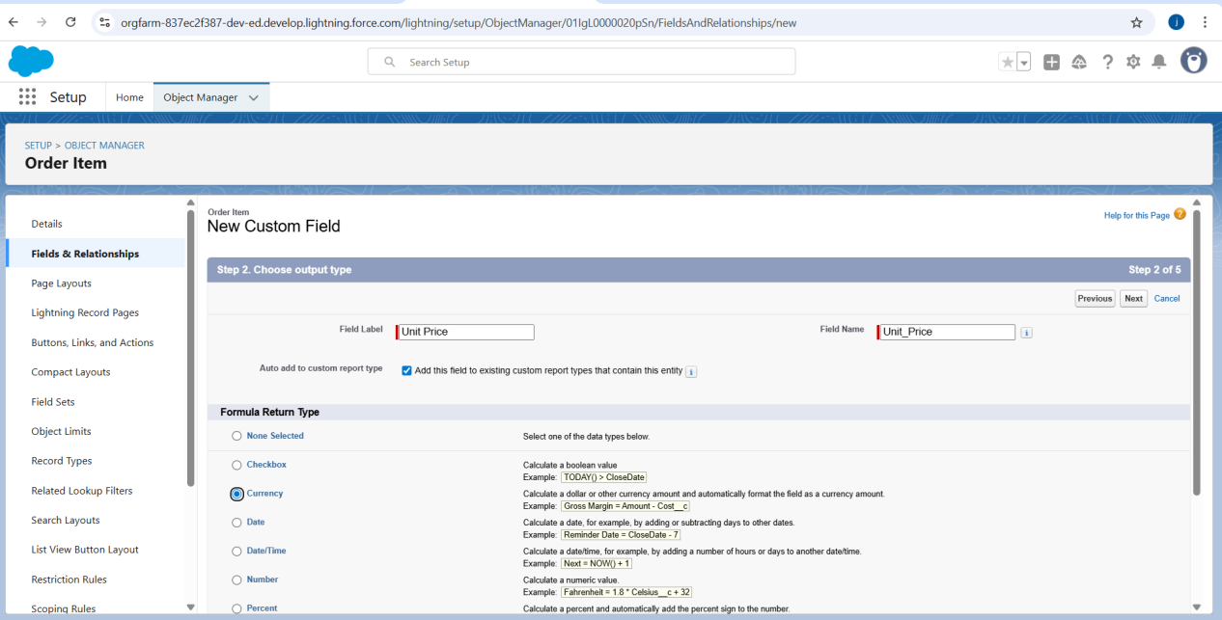

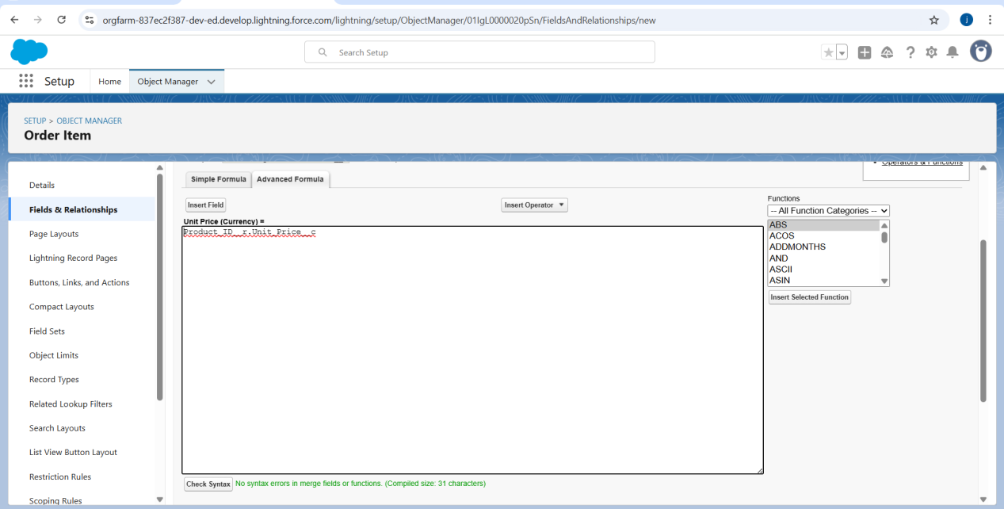

### **Creating a Amount Formula Field in Order Item object**

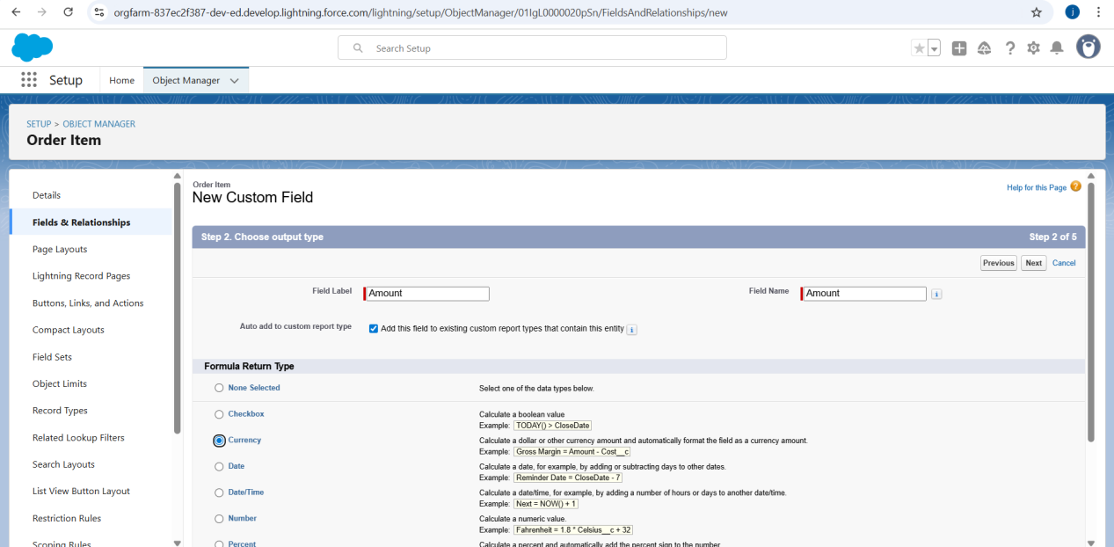

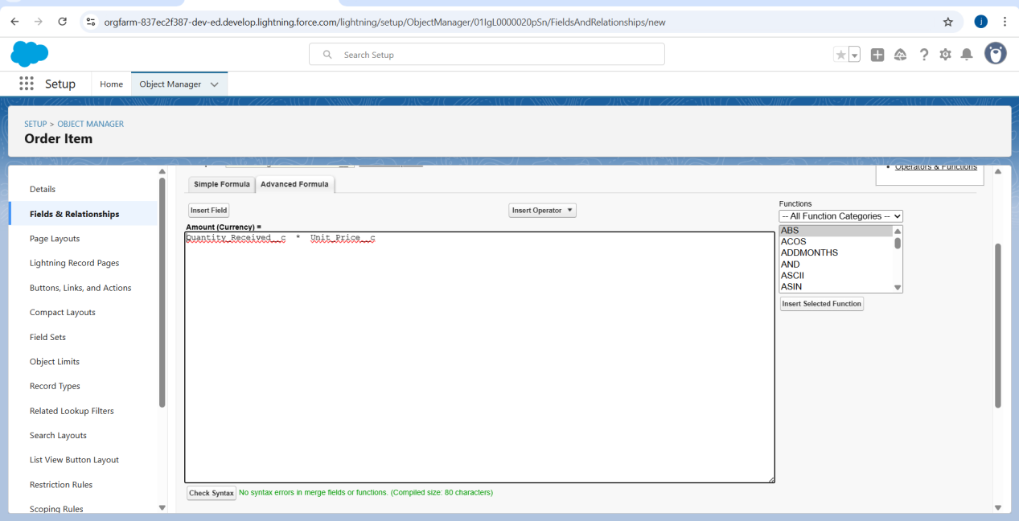

### **Creating a Picklist Field in Inventory Transaction Object**

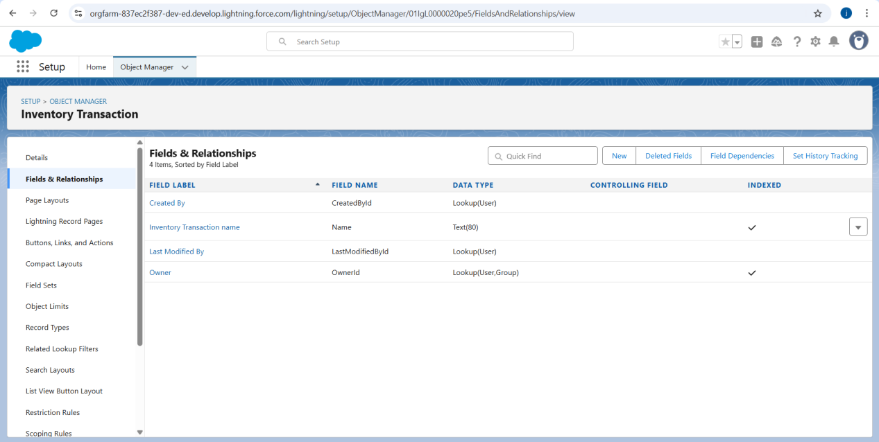

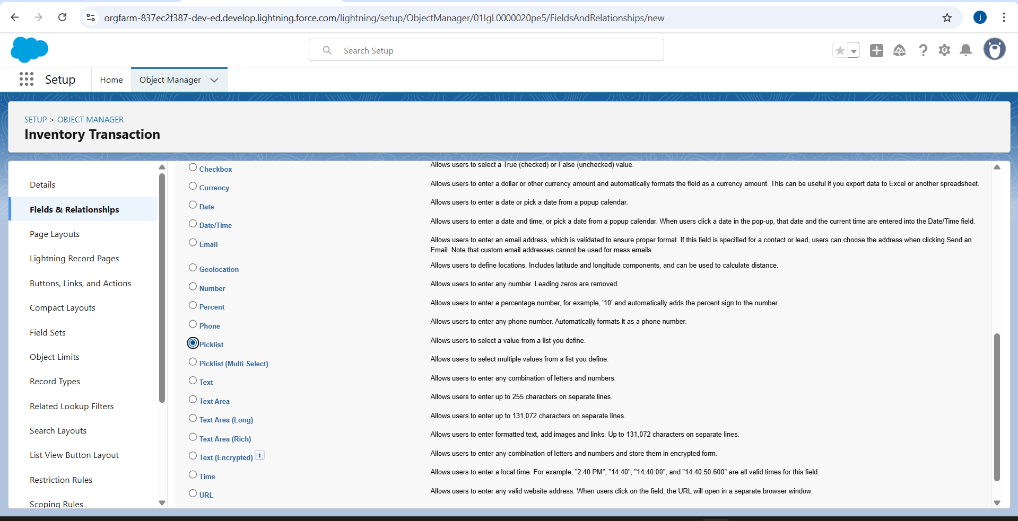

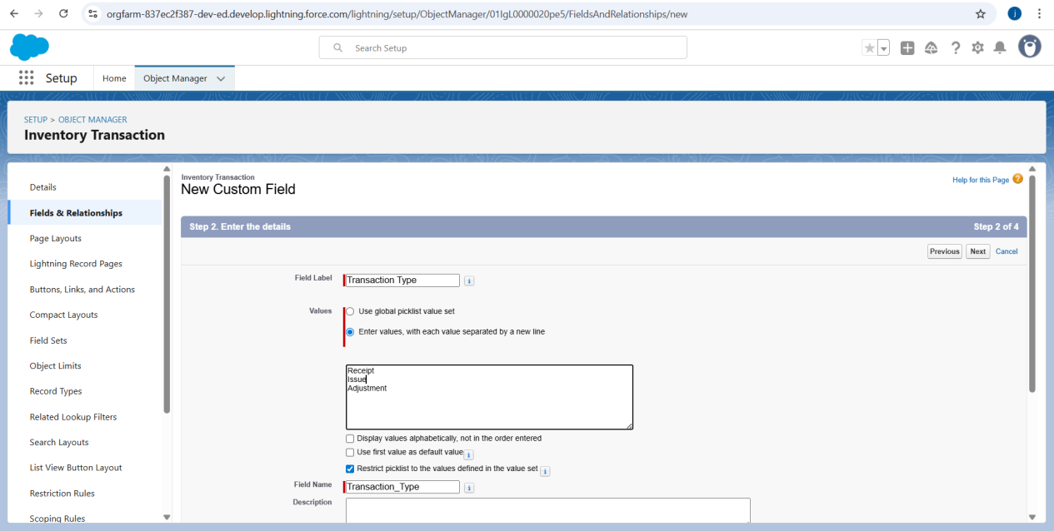

### **Creating a Total Order Cost Formula Field in Inventory Transaction Object**

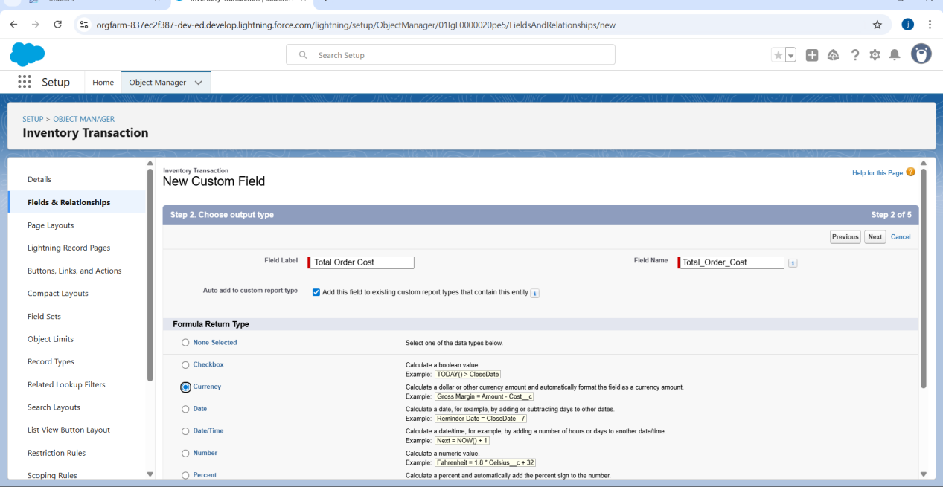

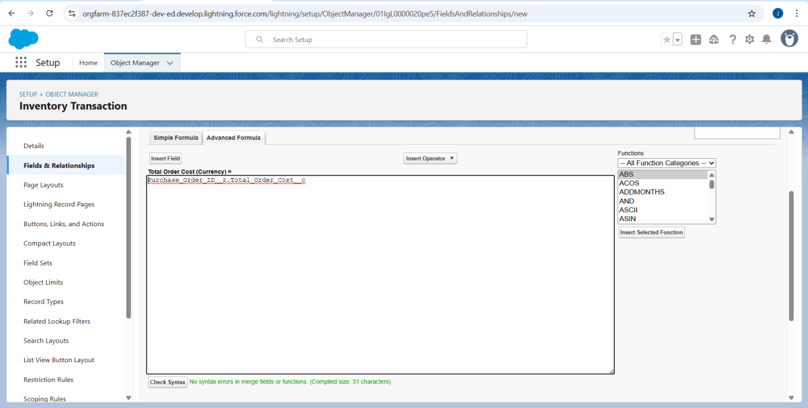**12.Creating a Phone Field in Supplier object**

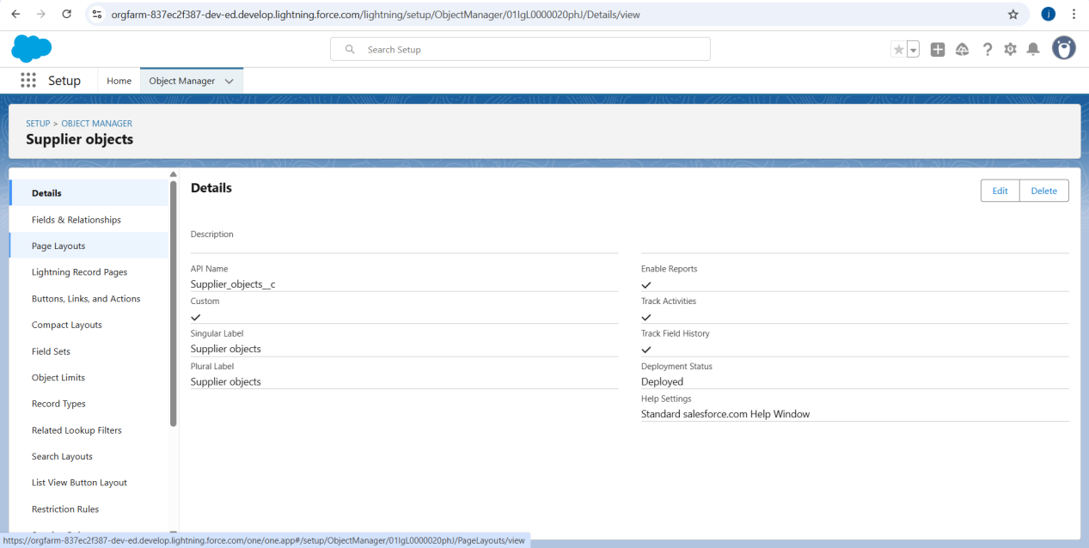

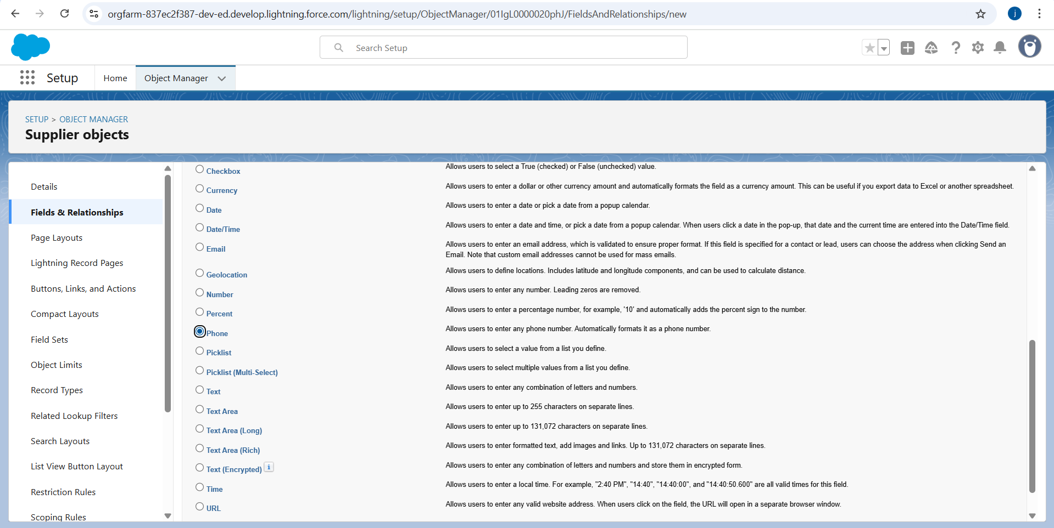

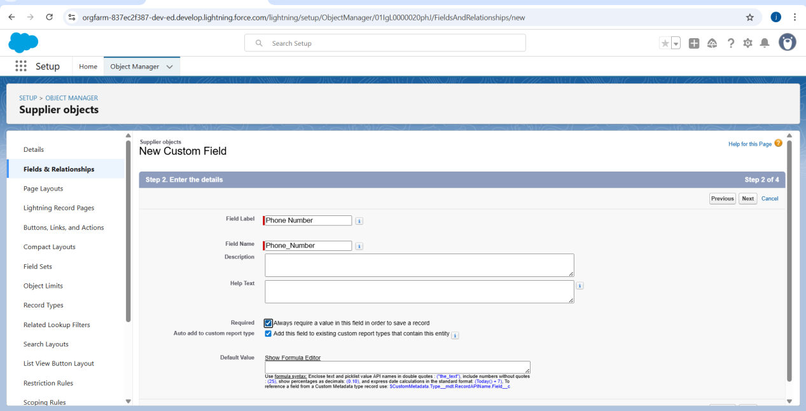**13.Creating a Email Field in Supplier object**

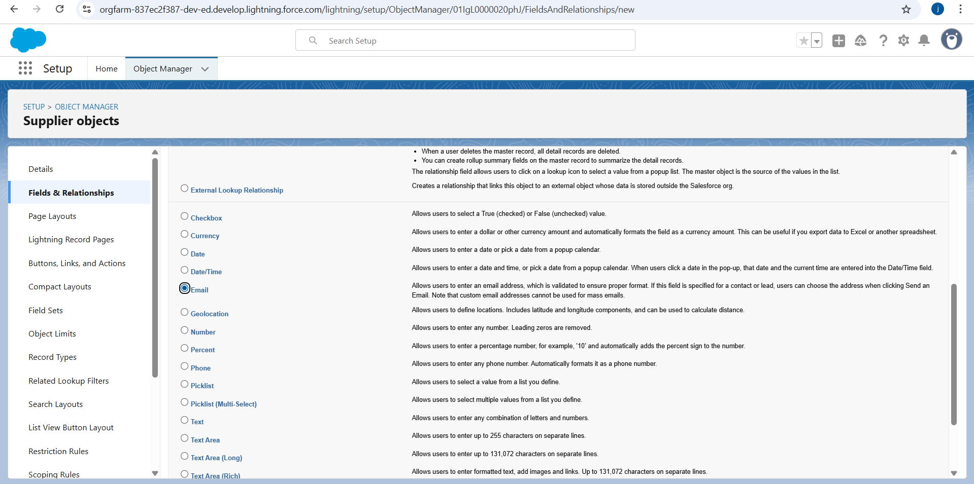

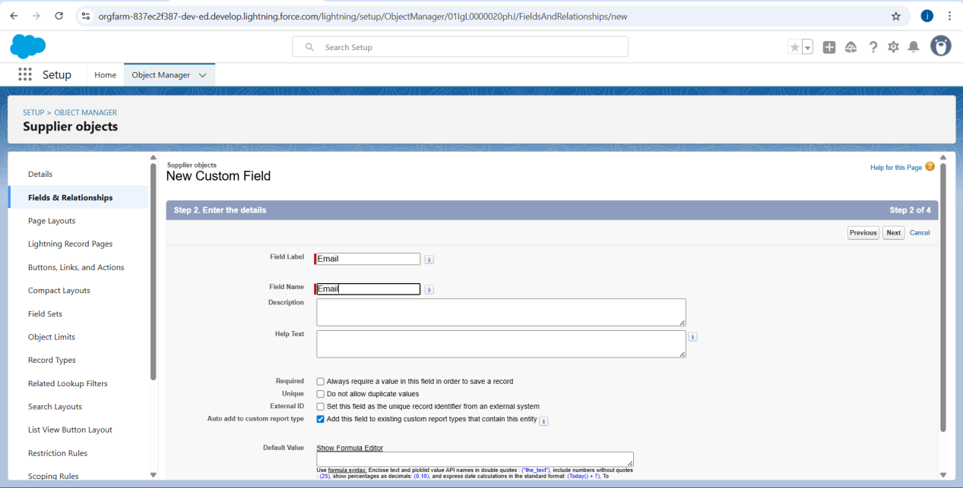**Milestone 6 -Editing of Page Layouts:**

### **Activity 1: To edit a Page Layout in Product Object**

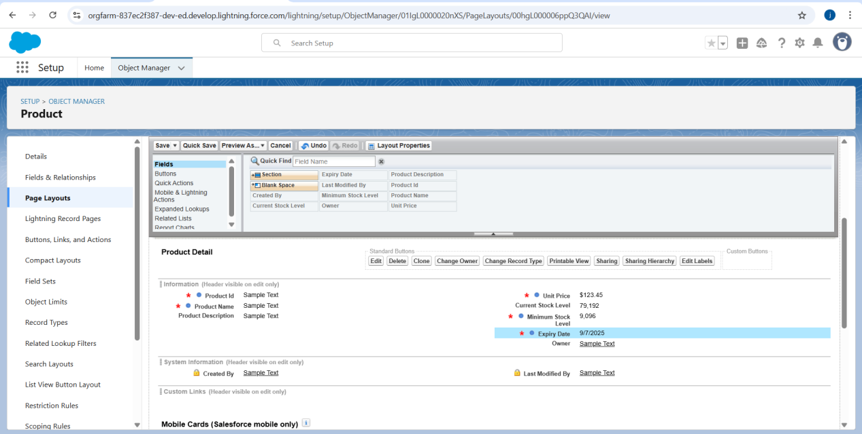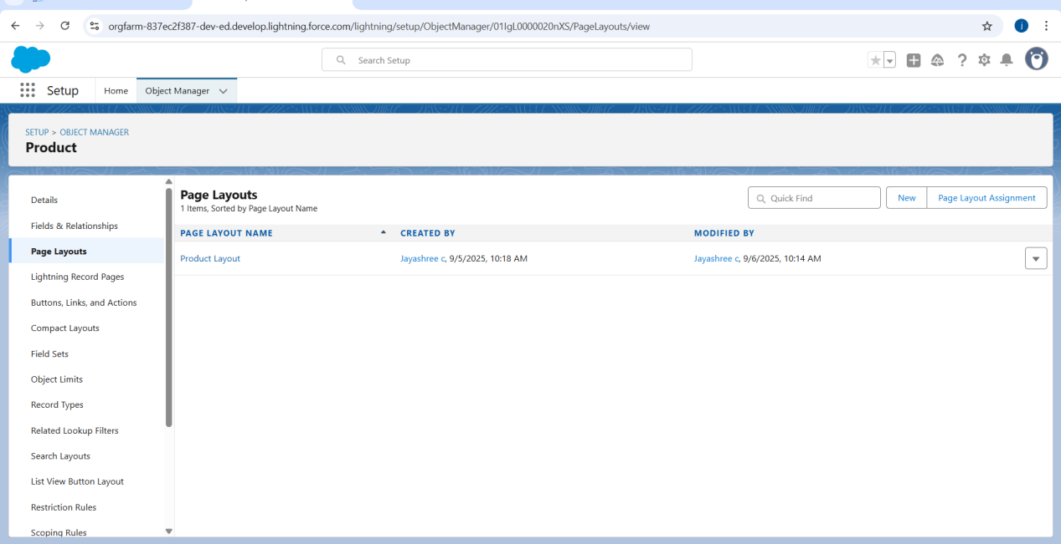

**Activty 2: To edit a Page Layout in Purchase Order Object**

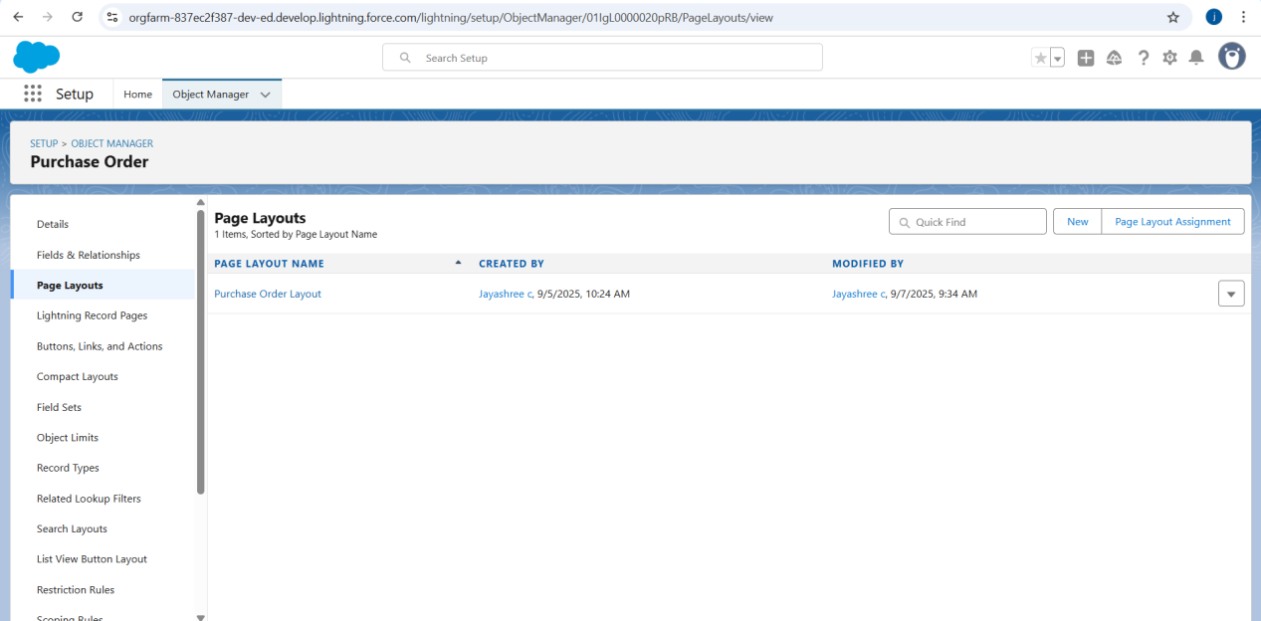

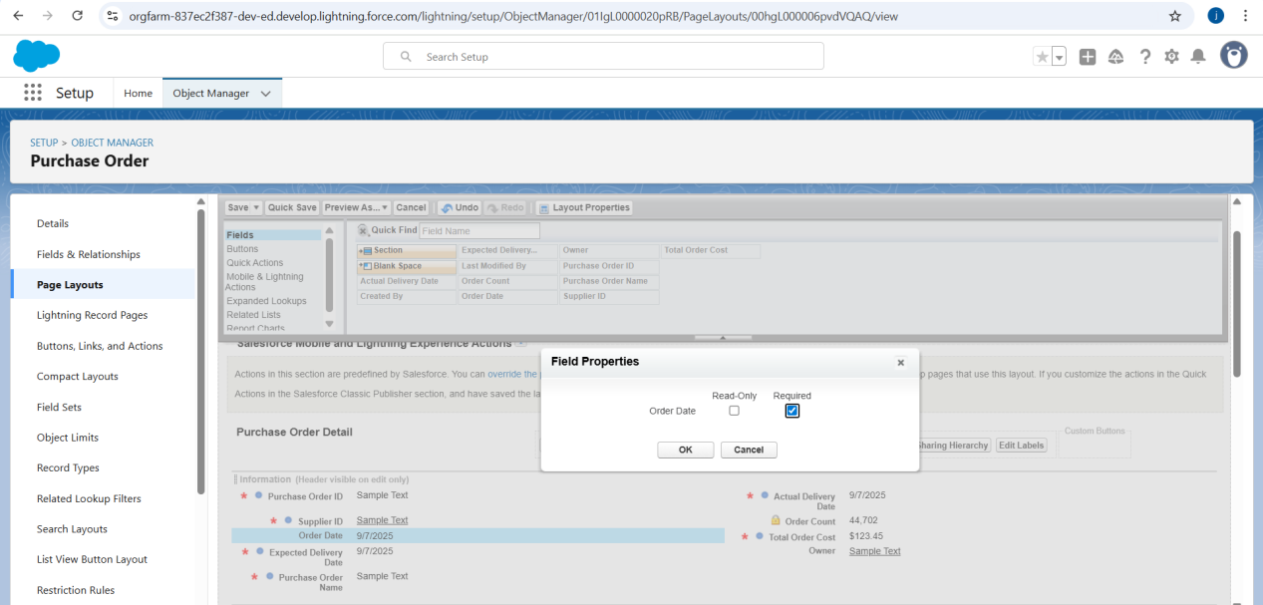

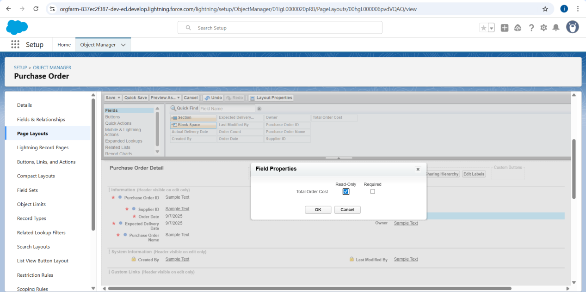

### **Activity 3: To edit a Page Layout in Order Item Object**

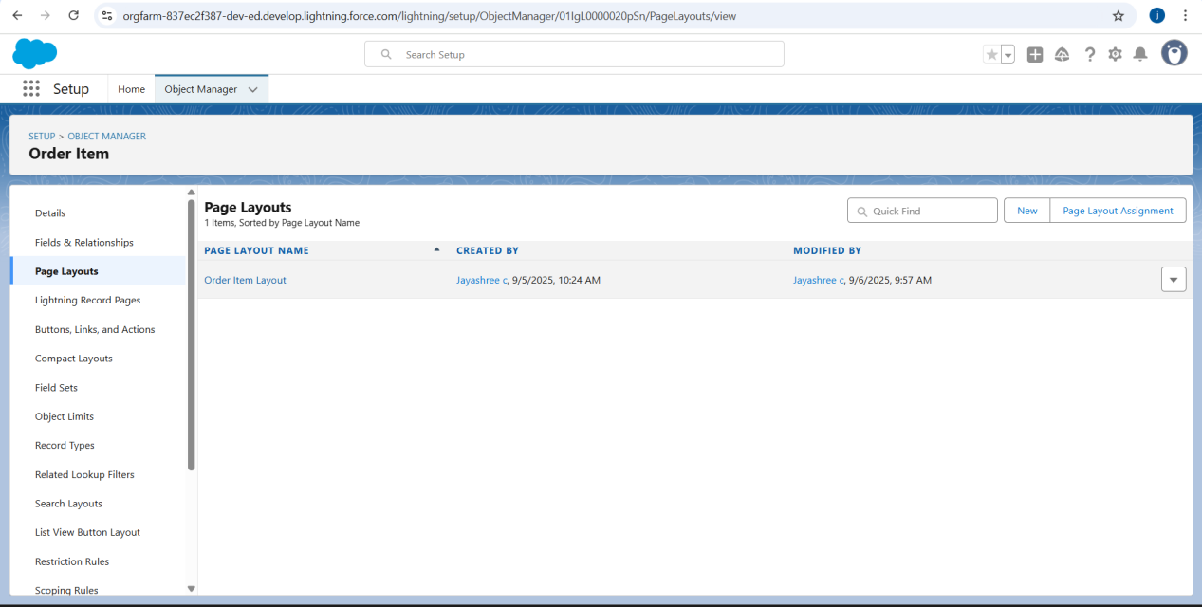

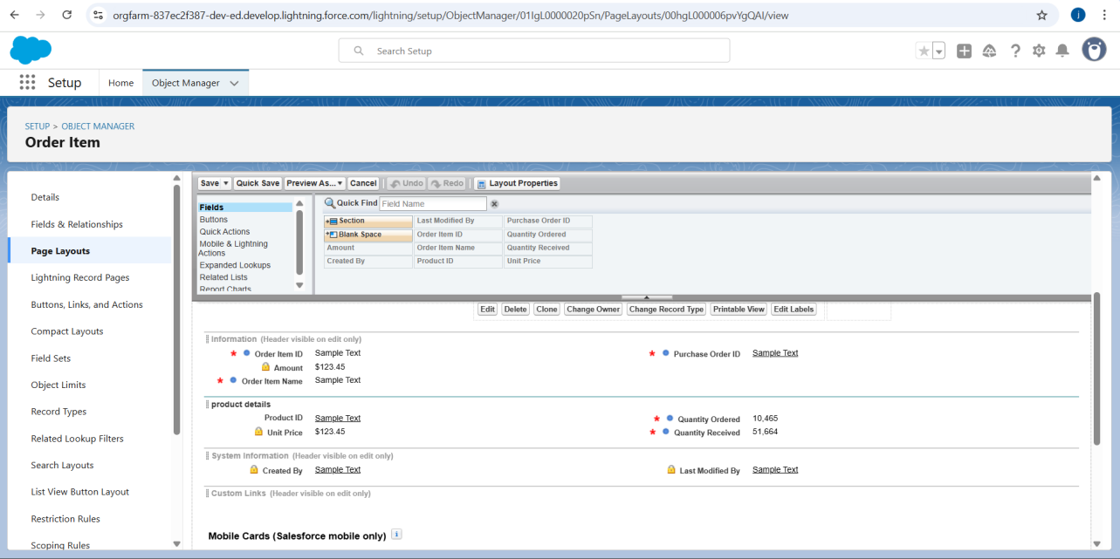

**Activity 4: To edit a Page Layout in Inventory Transaction Object**

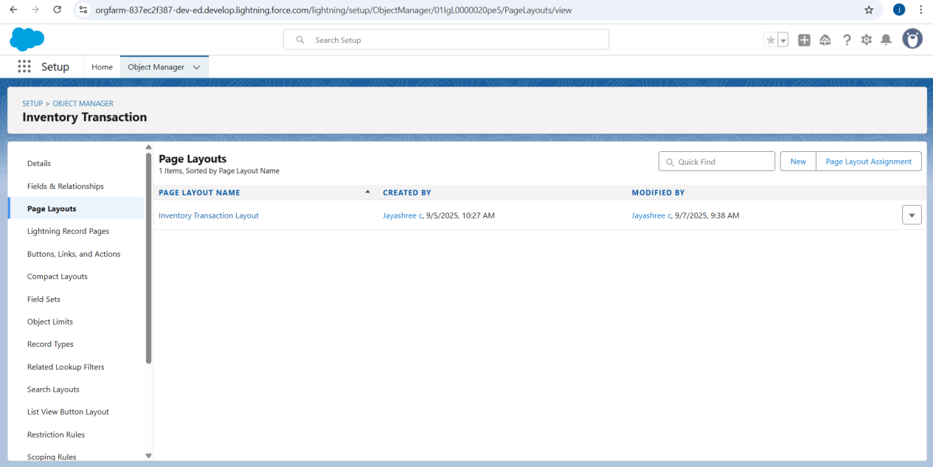

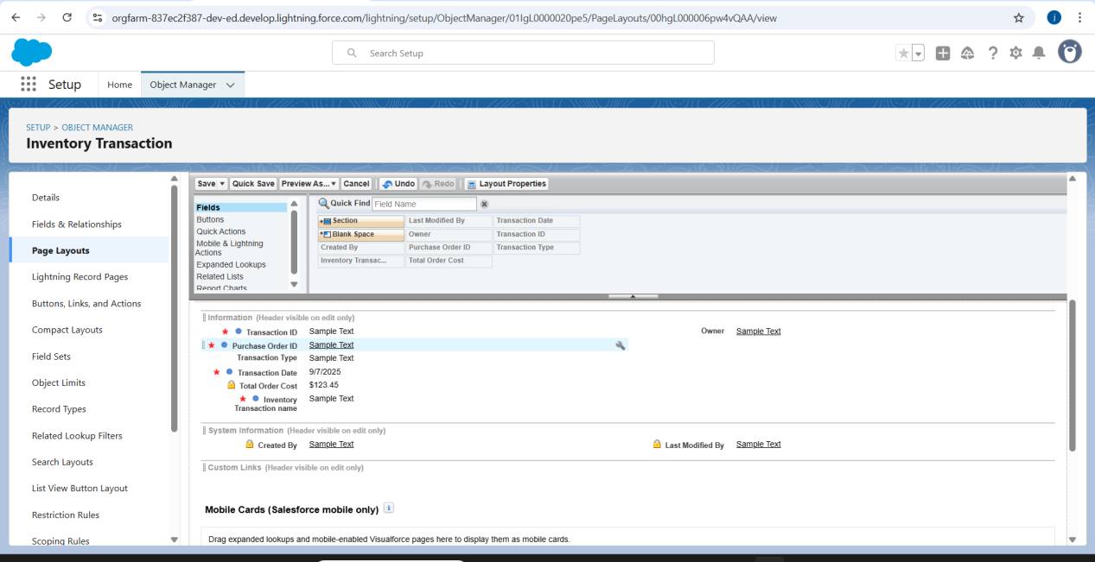**Activity 5: To edit a Page Layout in Supplier Object**

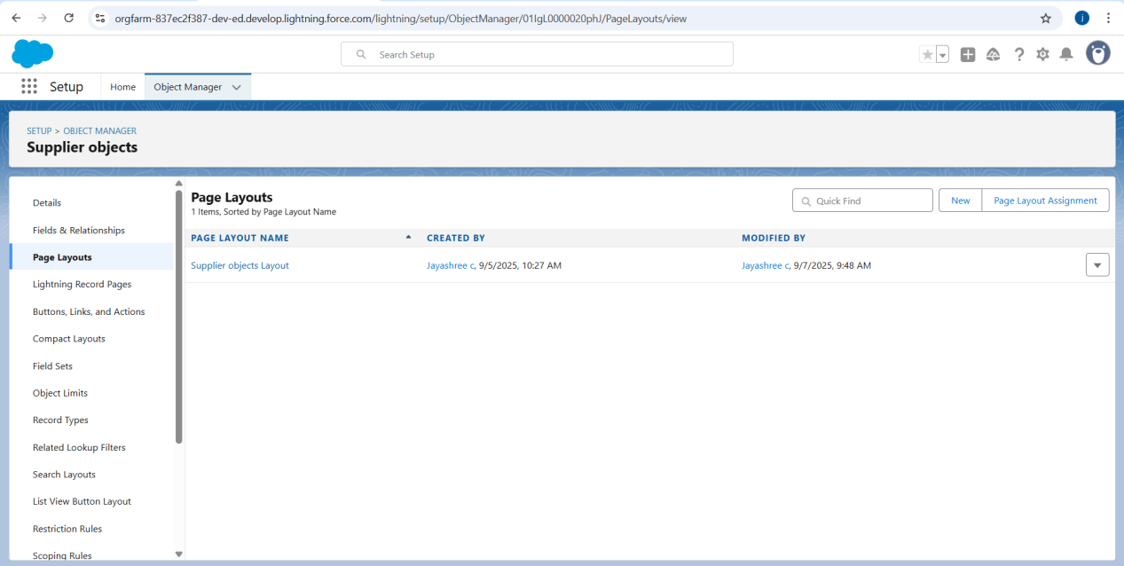

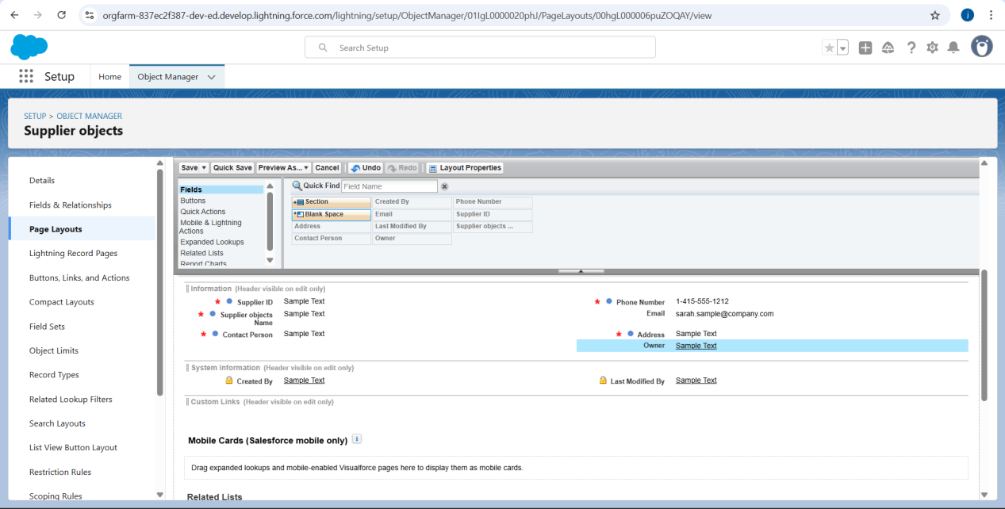**Milestone 7 - Compact Layouts**

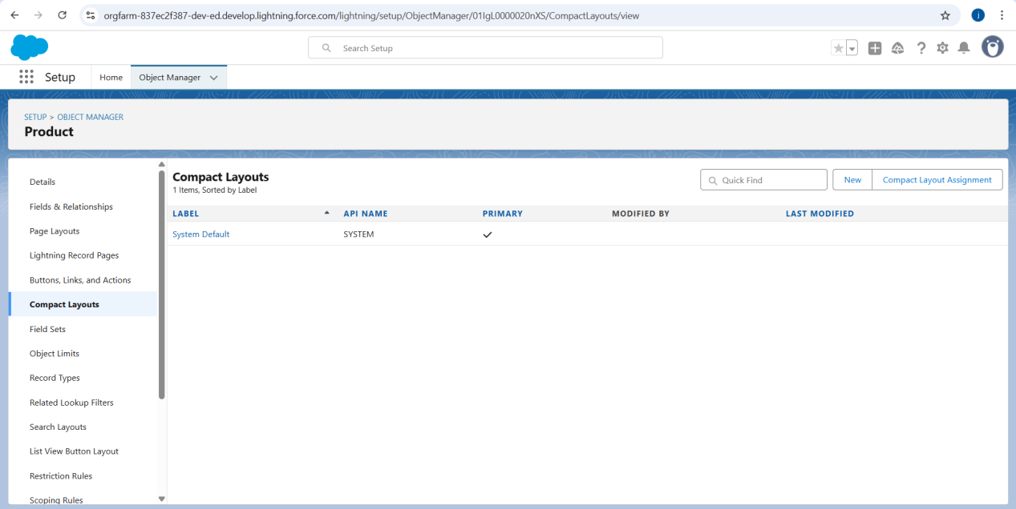

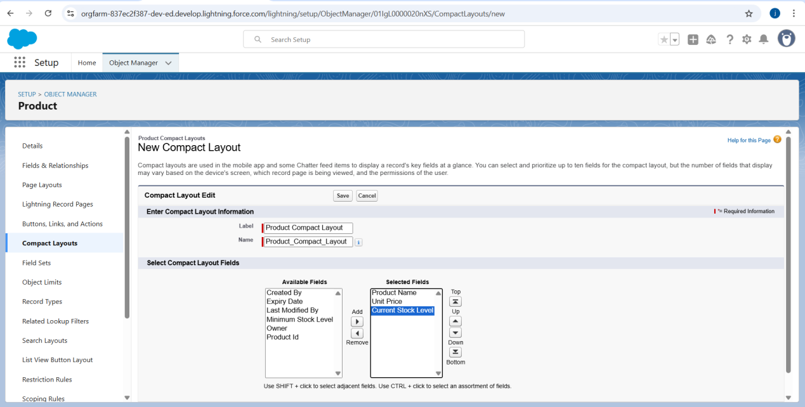

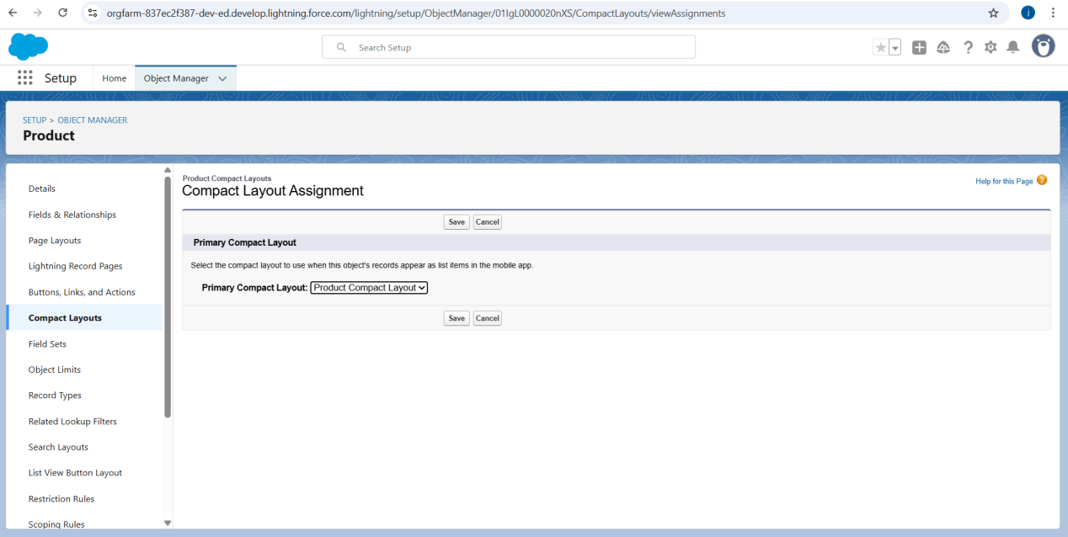**Activity 2: To create a Compact Layout to a Purchase Order Object**

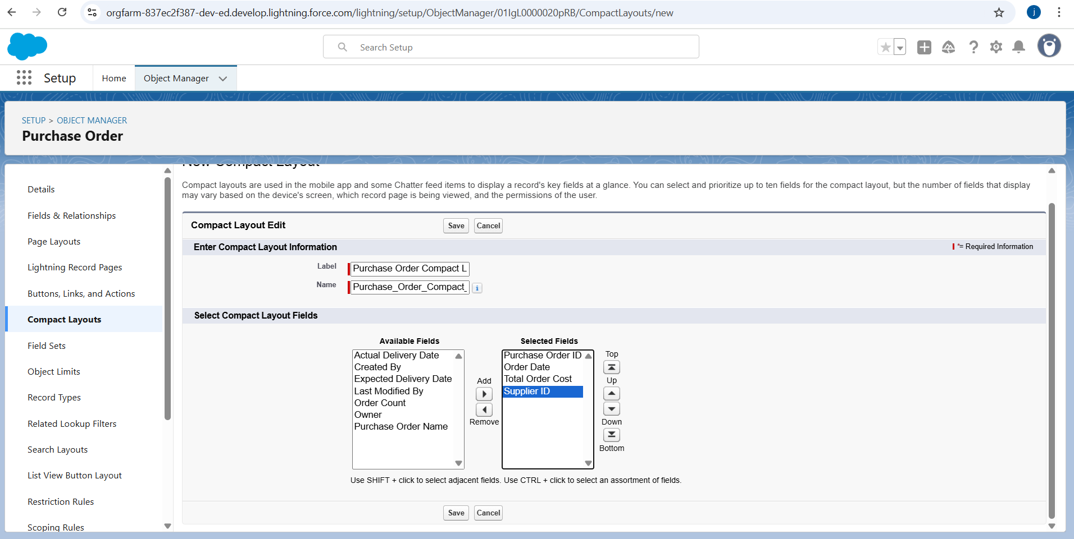

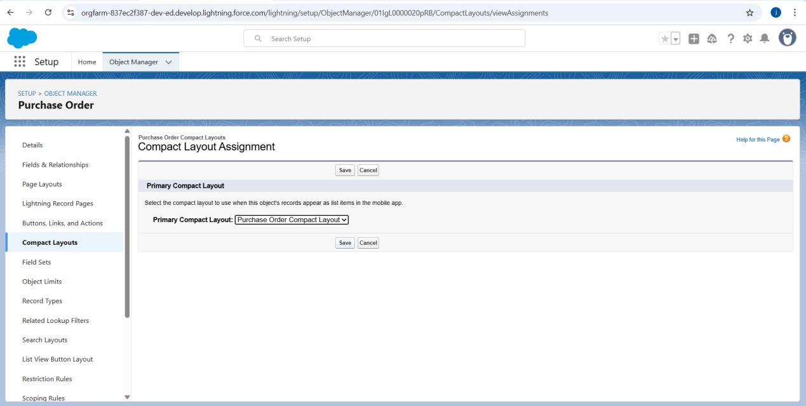

**Milestone 8 - Validation Rules**

**To create an Expected Delivery Date Validation rule to a Employee Object**

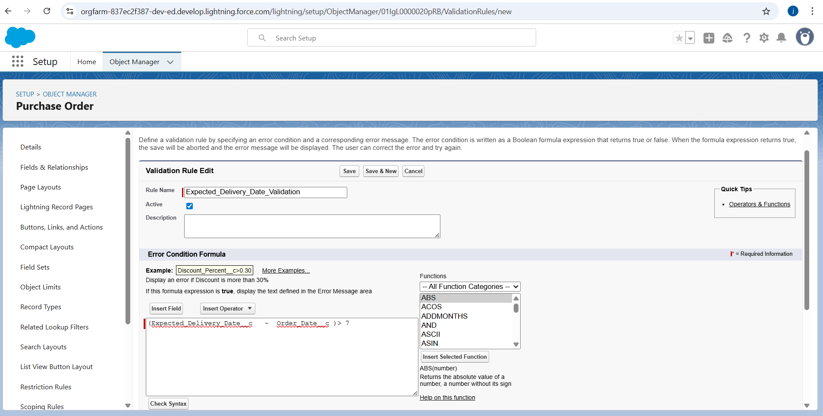

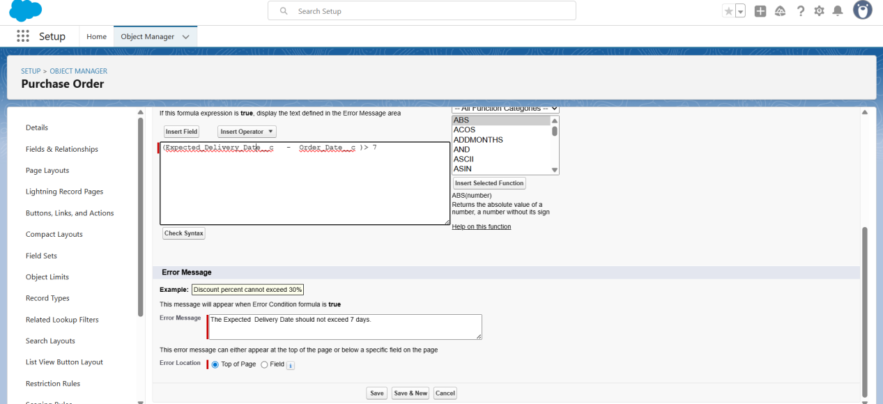**Milestone 9 - Profiles**

**Activity 1: To create an Inventory Manager Profile**

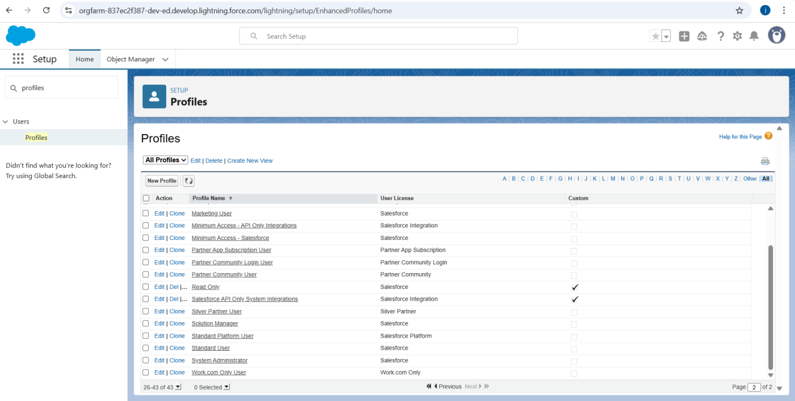

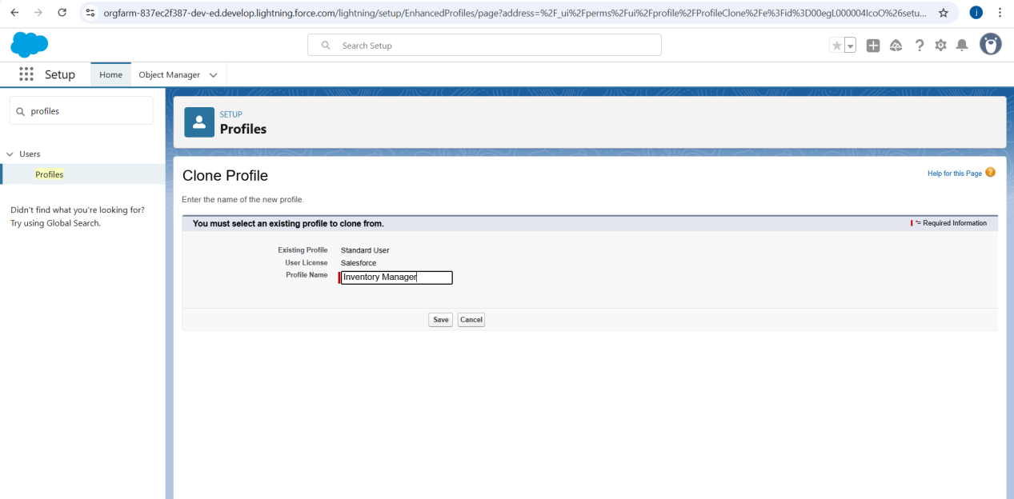

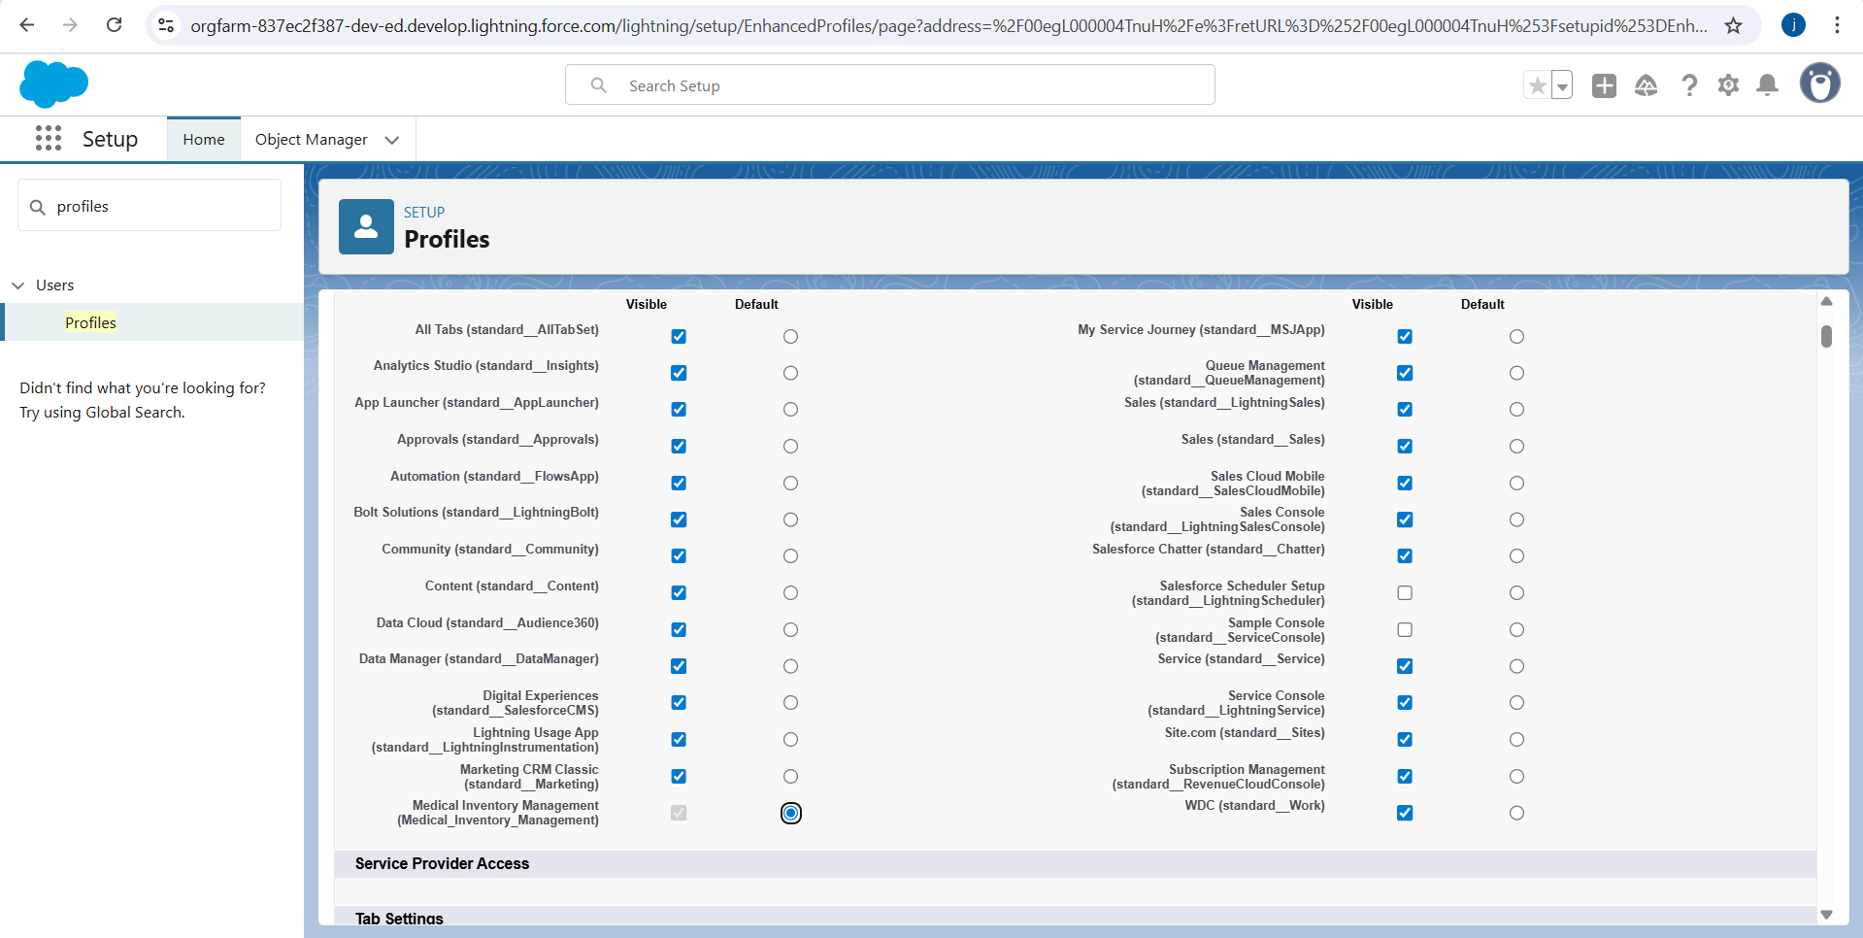

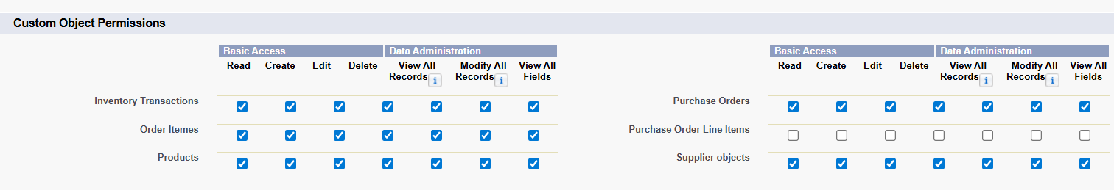

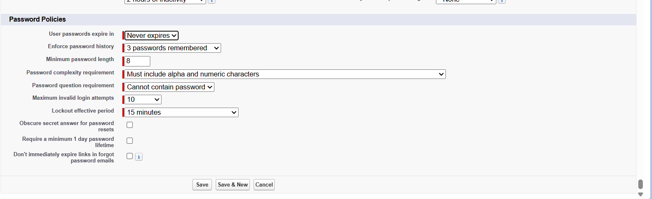

**Activity 2: To create an Purchase Manager Profile**

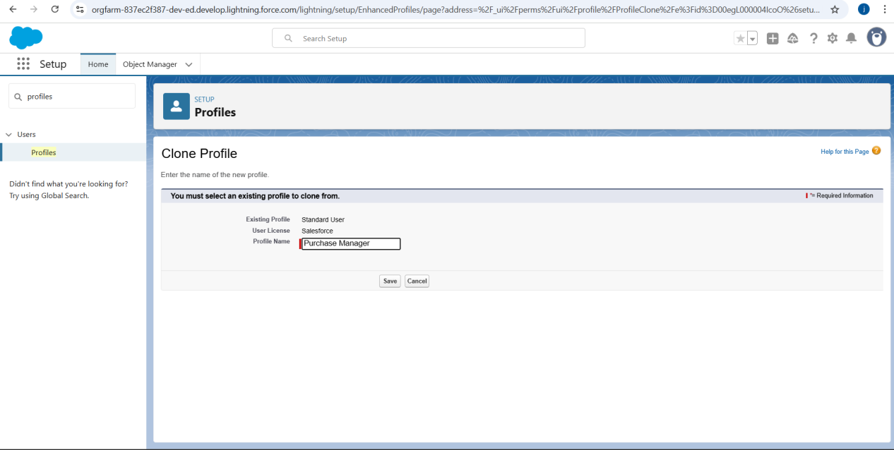

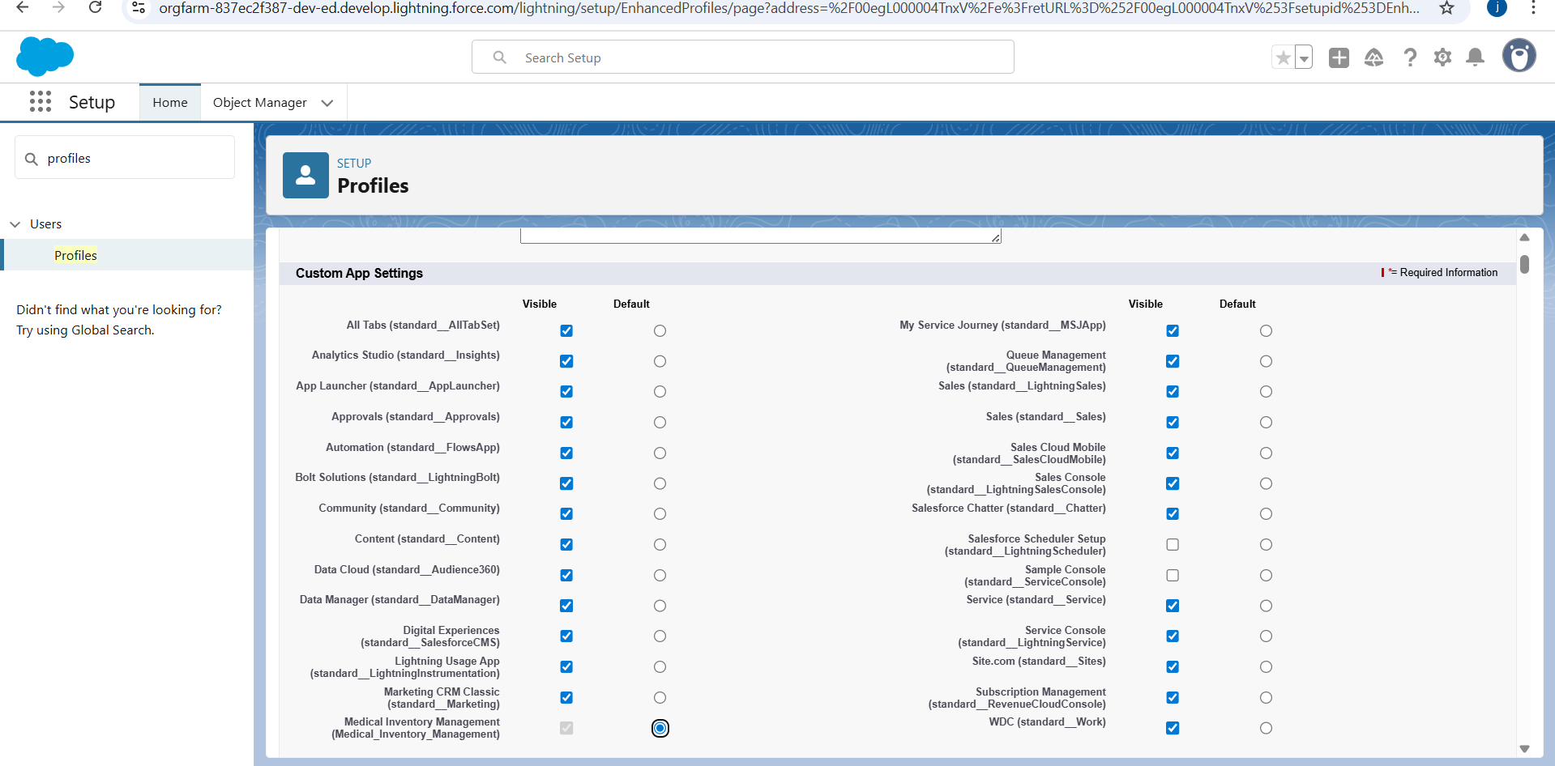

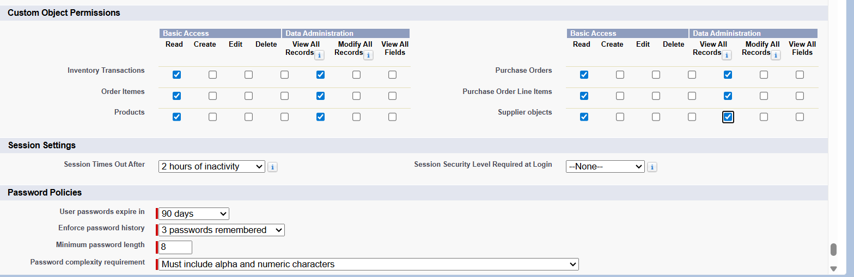

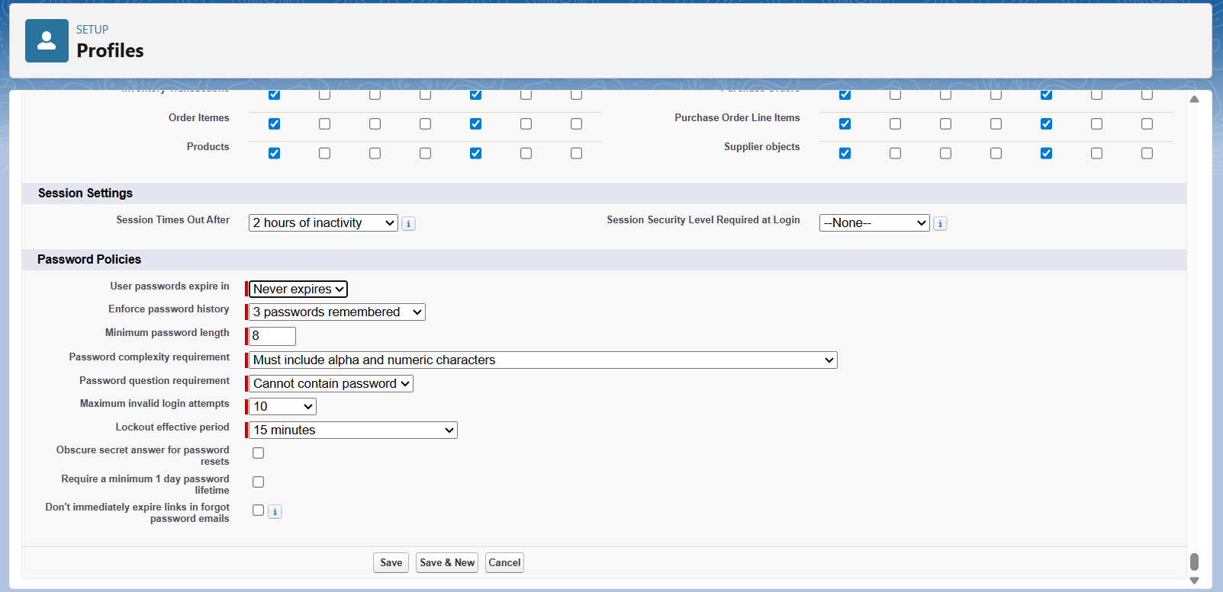**Milestone 10 - Roles**

### **Activity 1 : Create a Purchasing Manager Role.**

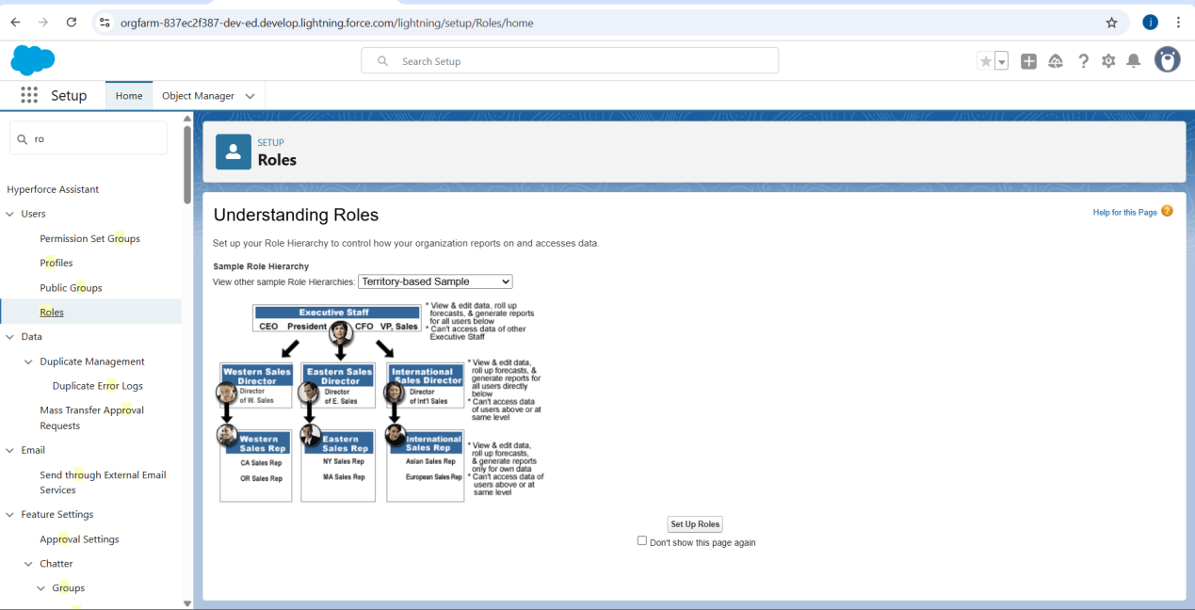

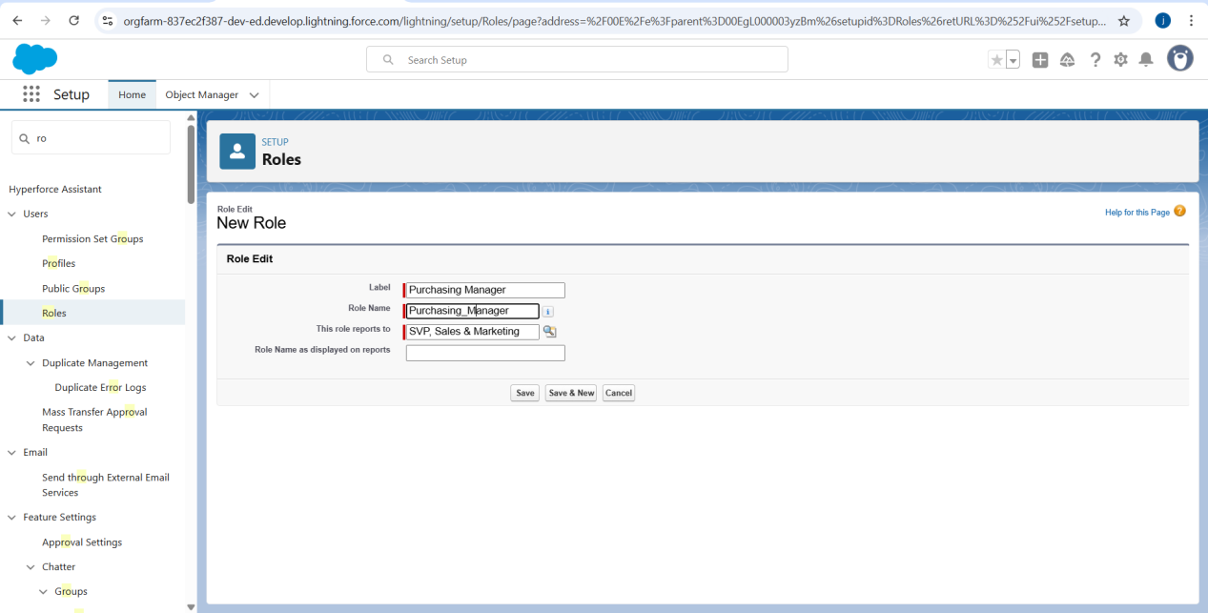

**Activity 2 : Create a Purchasing Manager Role.**

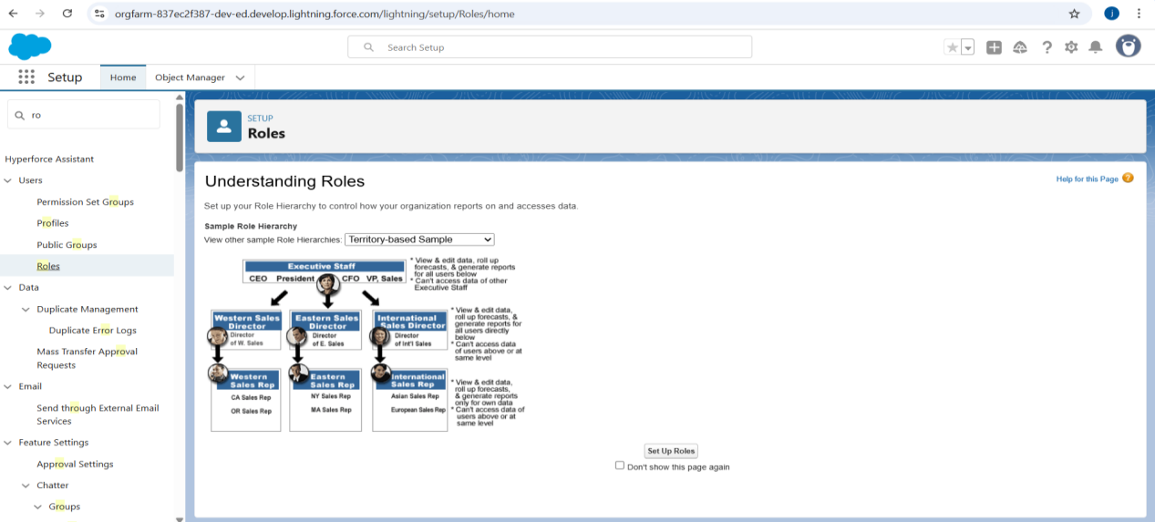

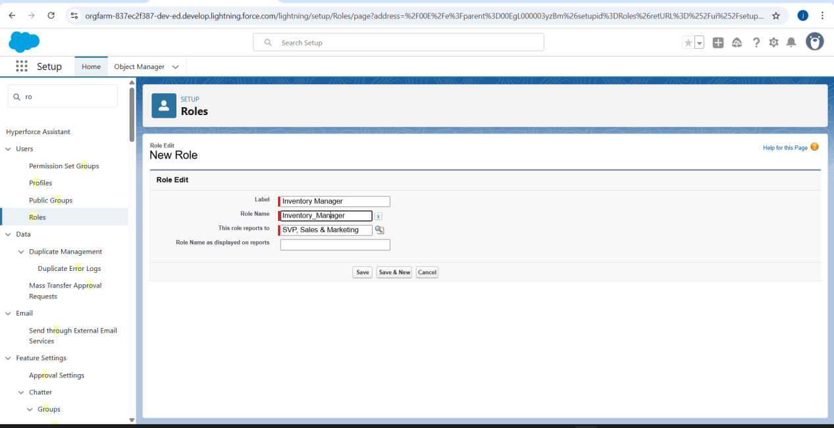**Milestone 12 - Permission Sets**

**Activity 1 : Create a Permission Set.**

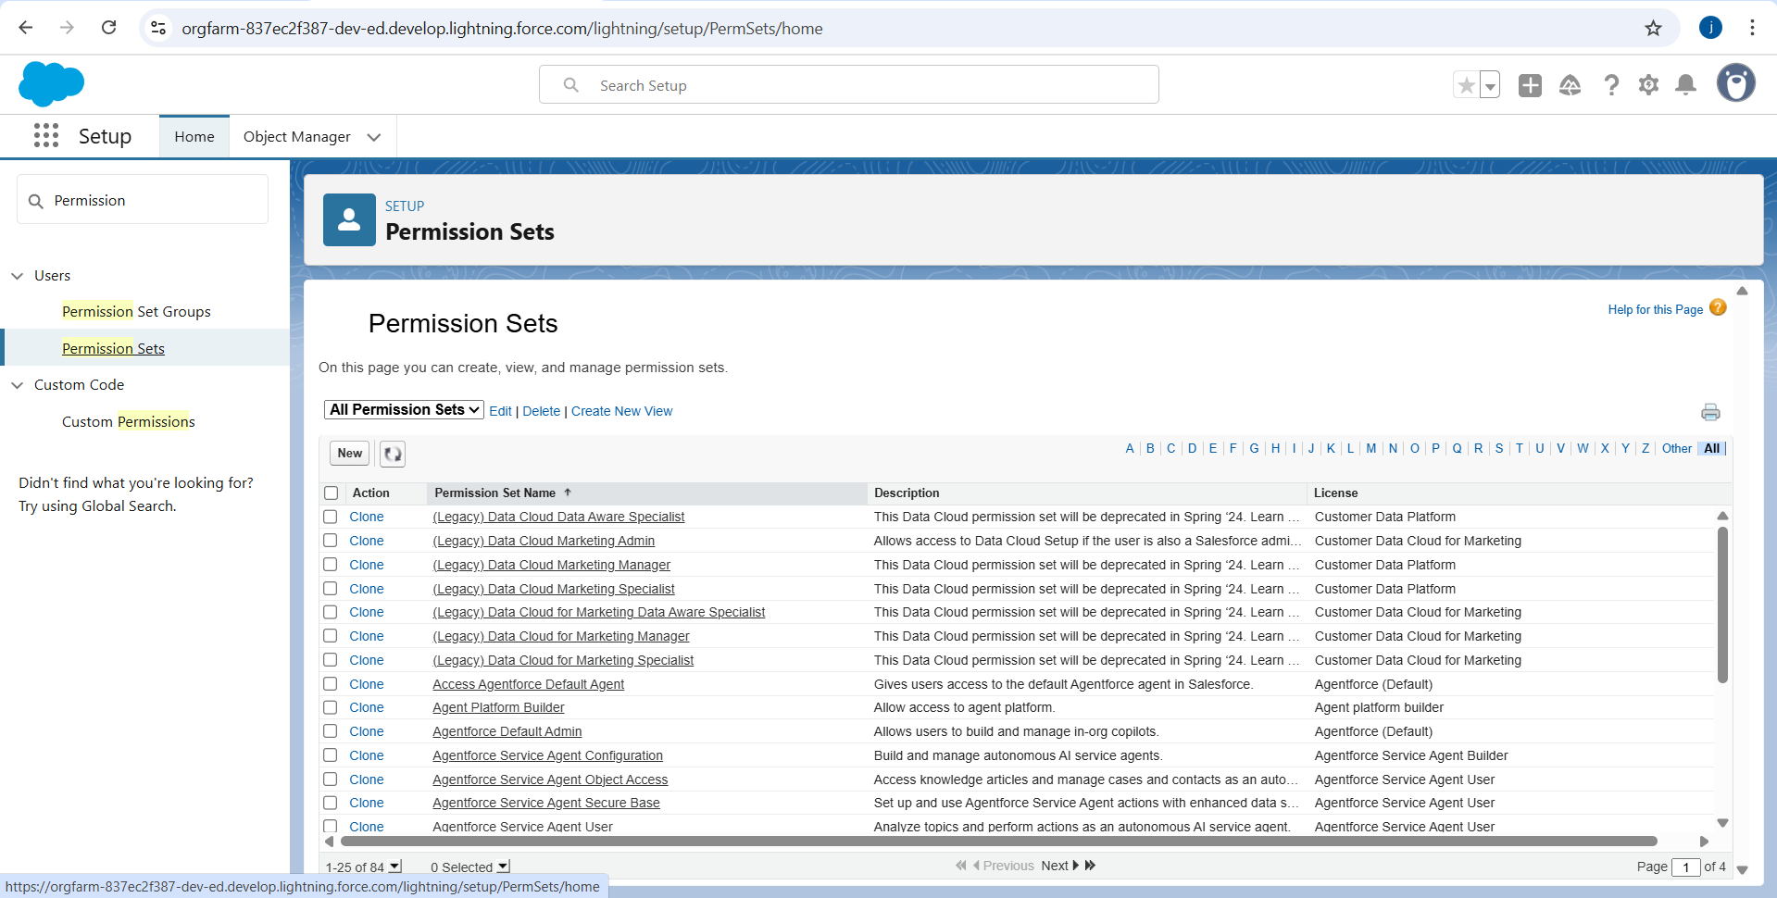

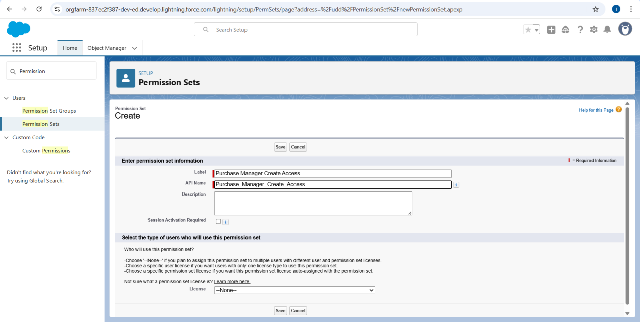

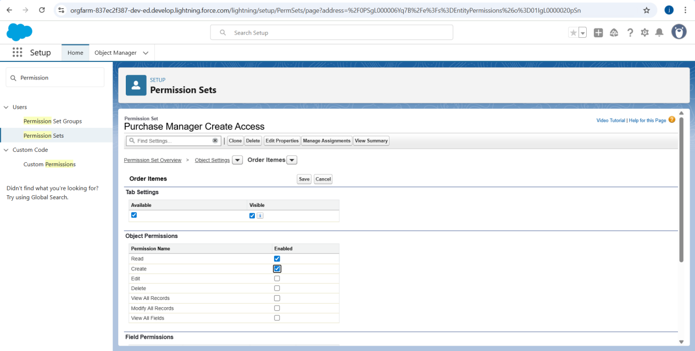

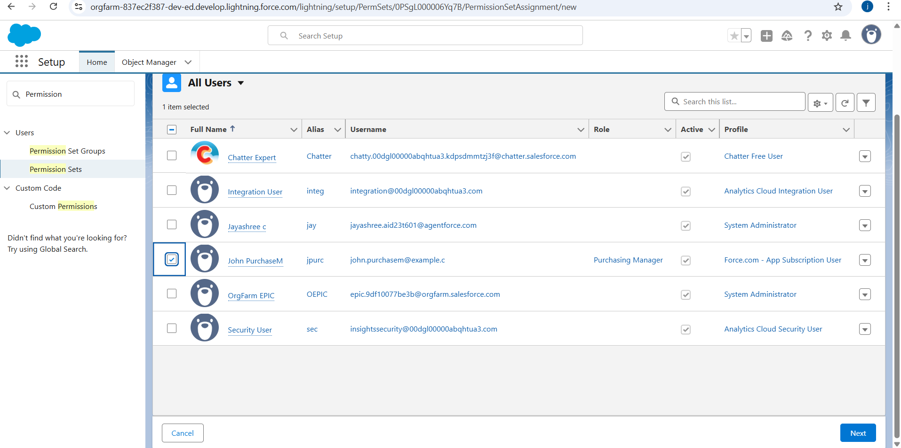

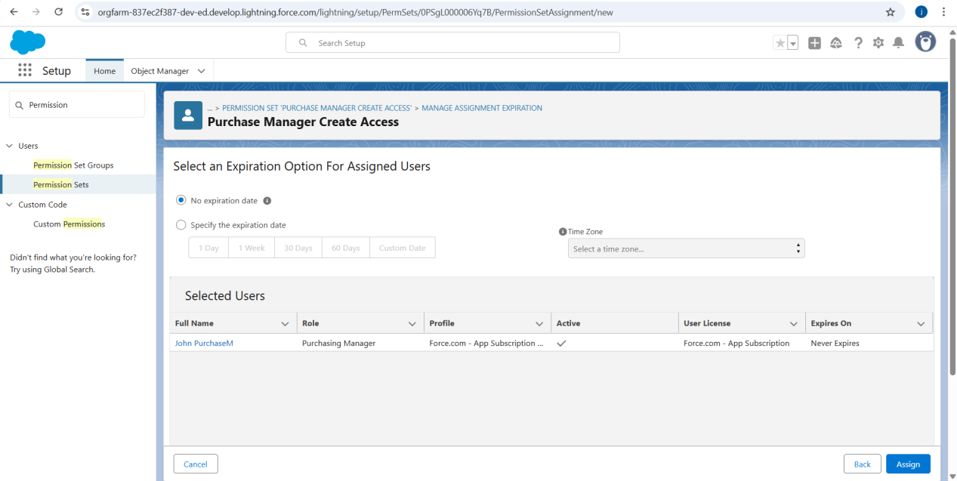

**Milestone 13 - Flows**

**Activity 1 : Create Flow to update the Actual Delivery Date.**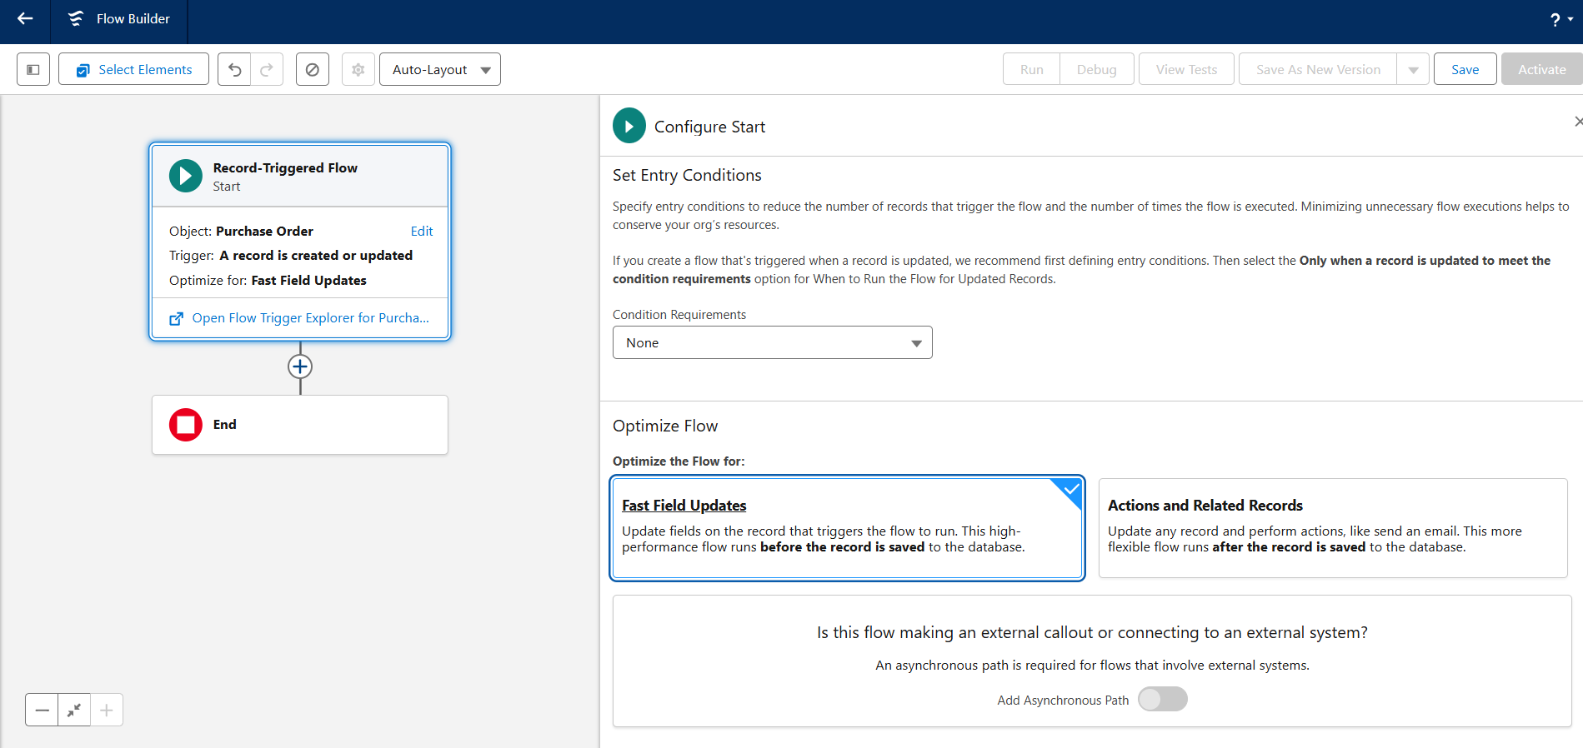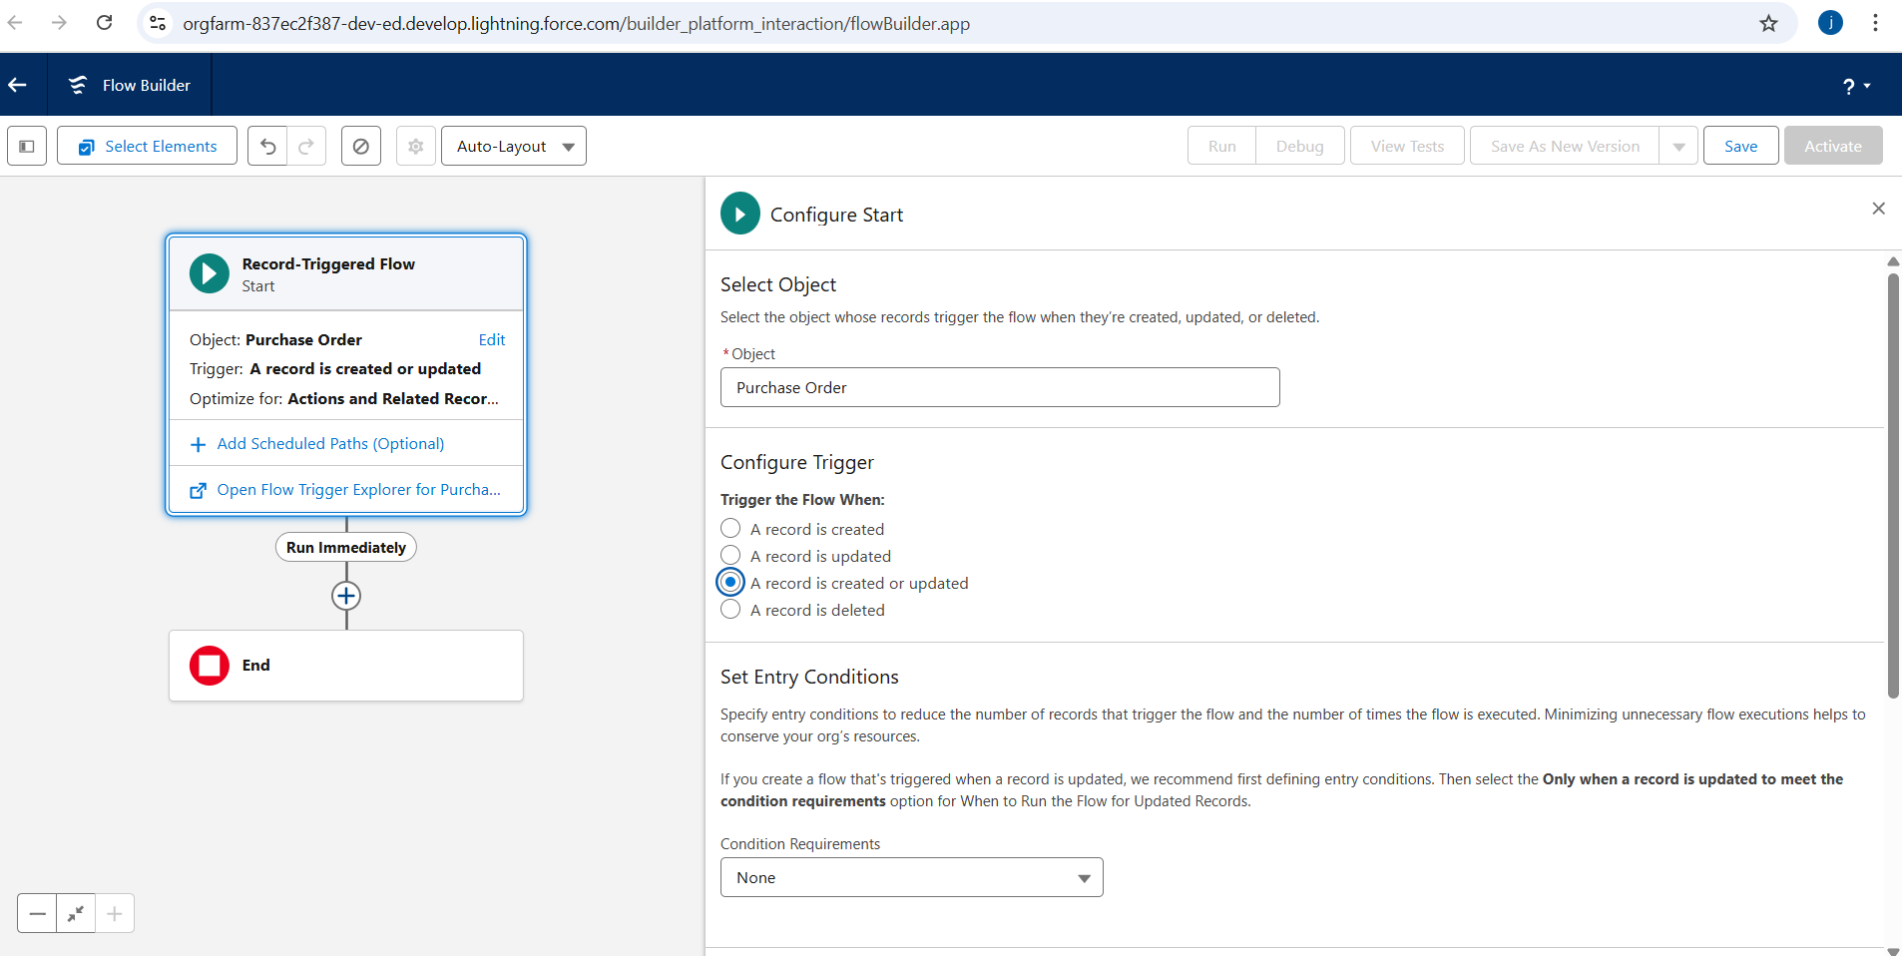

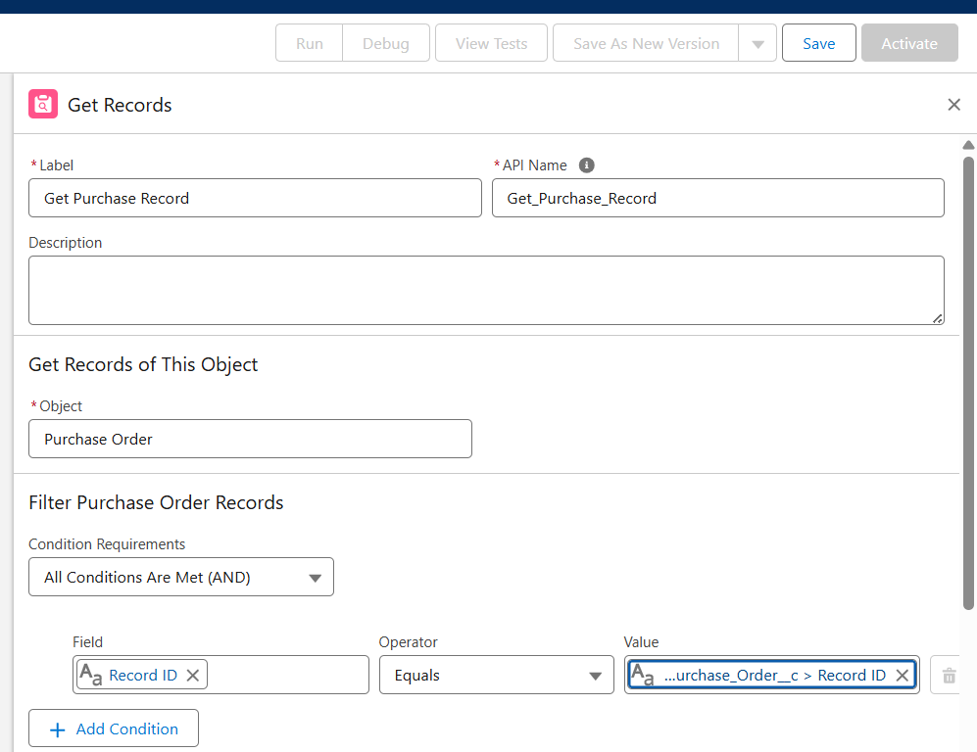

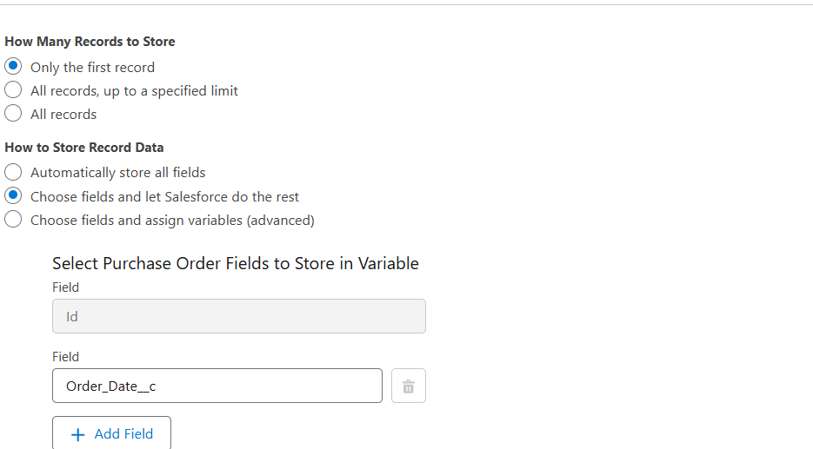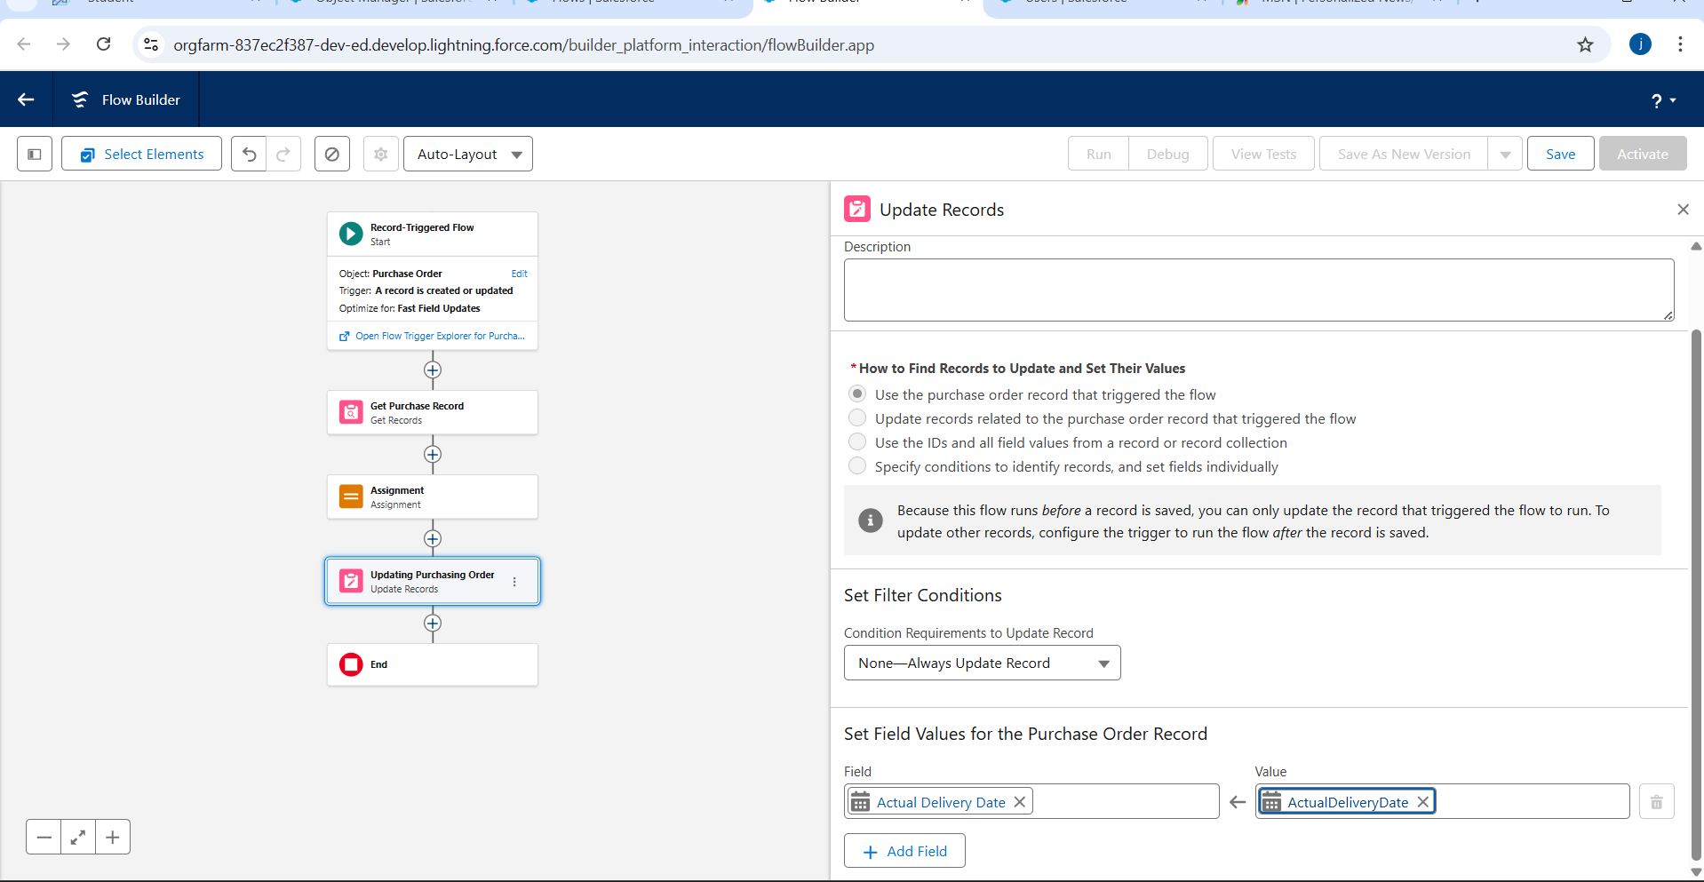

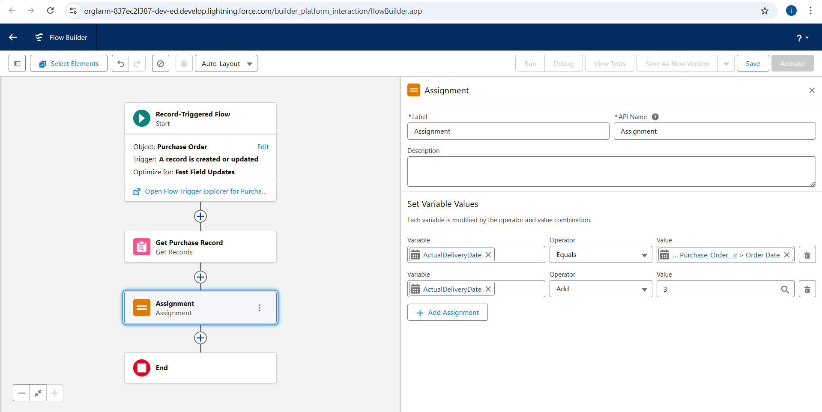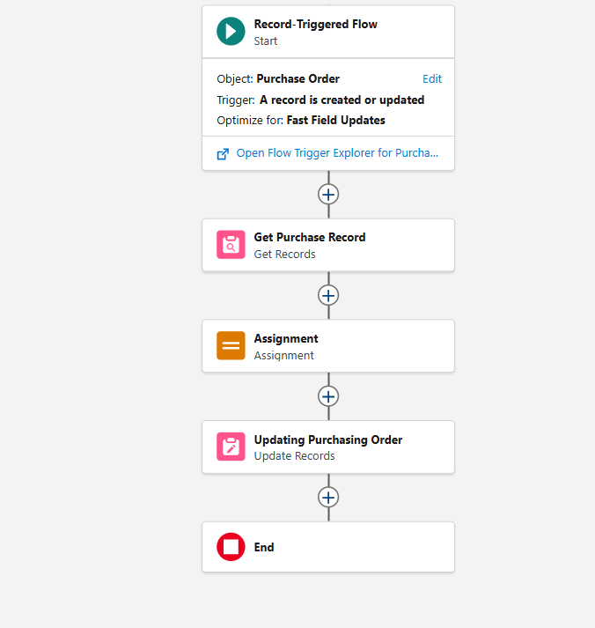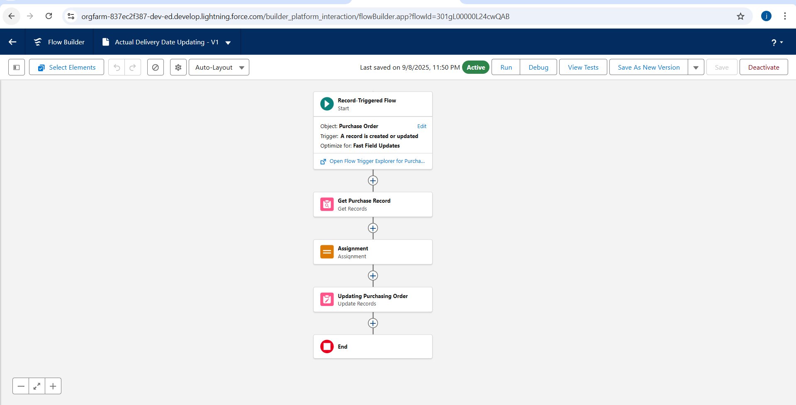

**Milestone 14 - Triggers**

### **Activity 1 : Create a Trigger to Calculate total amount on Order Item.**

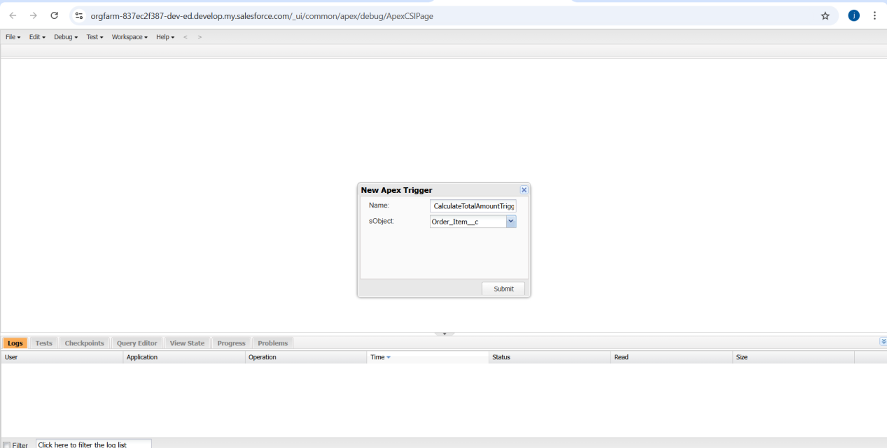

**APEX TRIGGER:**

trigger CalculateTotalAmountTrigger on Order_Item__c (after insert, after update, after delete, after undelete) {

// Call the handler class to handle the logic

CalculateTotalAmountHandler.calculateTotal(Trigger.new, Trigger.old, Trigger.isInsert, Trigger.isUpdate, Trigger.isDelete, Trigger.isUndelete);

}

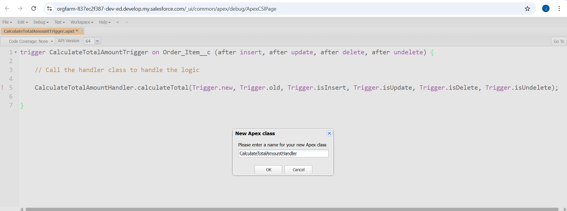

**APPEXCLASSES:**

public class CalculateTotalAmountHandler {

// Method to calculate the total amount for Purchase Orders based on related Order Items

public static void calculateTotal(List<Order_Item__c> newItems, List<Order_Item__c> oldItems, Boolean isInsert, Boolean isUpdate, Boolean isDelete, Boolean isUndelete) {

// Collect Purchase Order IDs affected by changes in Order_Item__c records

Set<Id> parentIds = new Set<Id>();

// For insert, update, and undelete scenarios

if (isInsert || isUpdate || isUndelete) {

for (Order_Item__c ordItem : newItems) {

parentIds.add(ordItem.Purchase_Order_Id__c);

}

}

// For update and delete scenarios

if (isUpdate || isDelete) {

for (Order_Item__c ordItem : oldItems) {

parentIds.add(ordItem.Purchase_Order_Id__c);

}

}

// Calculate the total amounts for affected Purchase Orders

Map<Id, Decimal> purchaseToUpdateMap = new Map<Id, Decimal>();

if (!parentIds.isEmpty()) {

// Perform an aggregate query to sum the Amount__c for each Purchase Order

List<AggregateResult> aggrList = [

SELECT Purchase_Order_Id__c, SUM(Amount__c) totalAmount

FROM Order_Item__c

WHERE Purchase_Order_Id__c IN :parentIds

GROUP BY Purchase_Order_Id__c

];

// Map the result to Purchase Order IDs

for (AggregateResult aggr : aggrList) {

Id purchaseOrderId = (Id)aggr.get('Purchase_Order_Id__c');

Decimal totalAmount = (Decimal)aggr.get('totalAmount');

purchaseToUpdateMap.put(purchaseOrderId, totalAmount);

}

// Prepare Purchase Order records for update

List<Purchase_Order__c> purchaseToUpdate = new List<Purchase_Order__c>();

for (Id purchaseOrderId : purchaseToUpdateMap.keySet()) {

Purchase_Order__c purchaseOrder = new Purchase_Order__c(Id = purchaseOrderId, Total_Order_cost__c = purchaseToUpdateMap.get(purchaseOrderId));

purchaseToUpdate.add(purchaseOrder);

}

// Update Purchase Orders if there are any changes

if (!purchaseToUpdate.isEmpty()) {

update purchaseToUpdate;

}

}

}}

### **Milestone 15 - Reports**

### **Activity 1: Create a Purchase Orders based on Suppliers(Summary) Report**

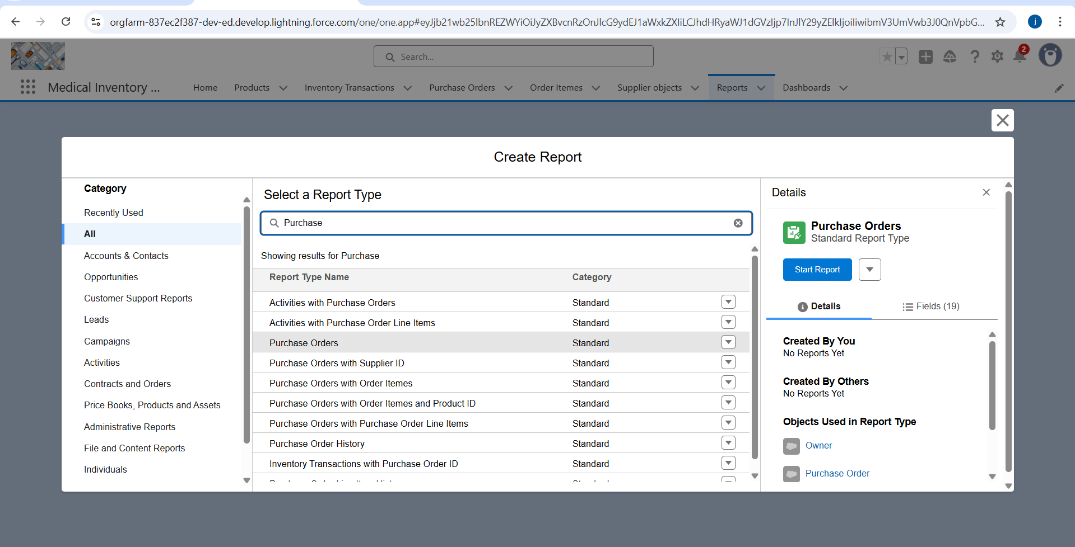

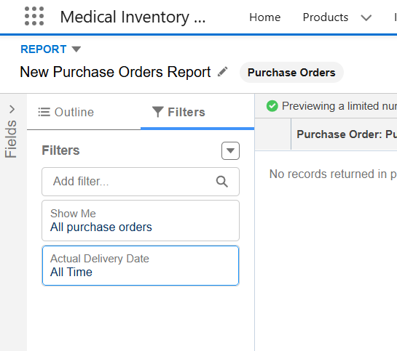

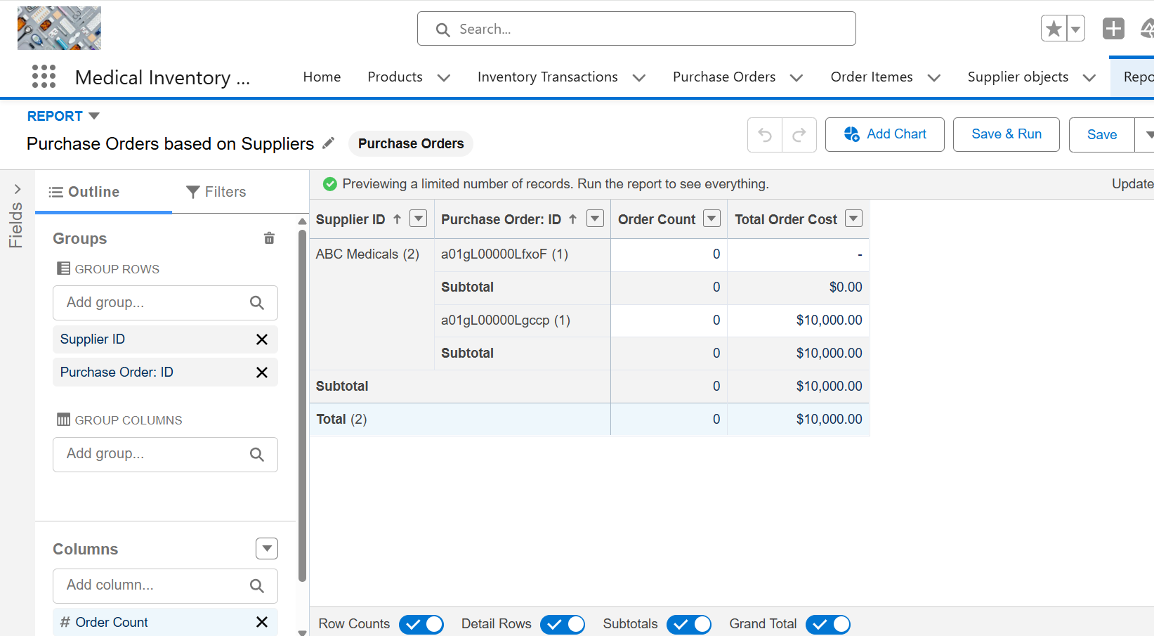

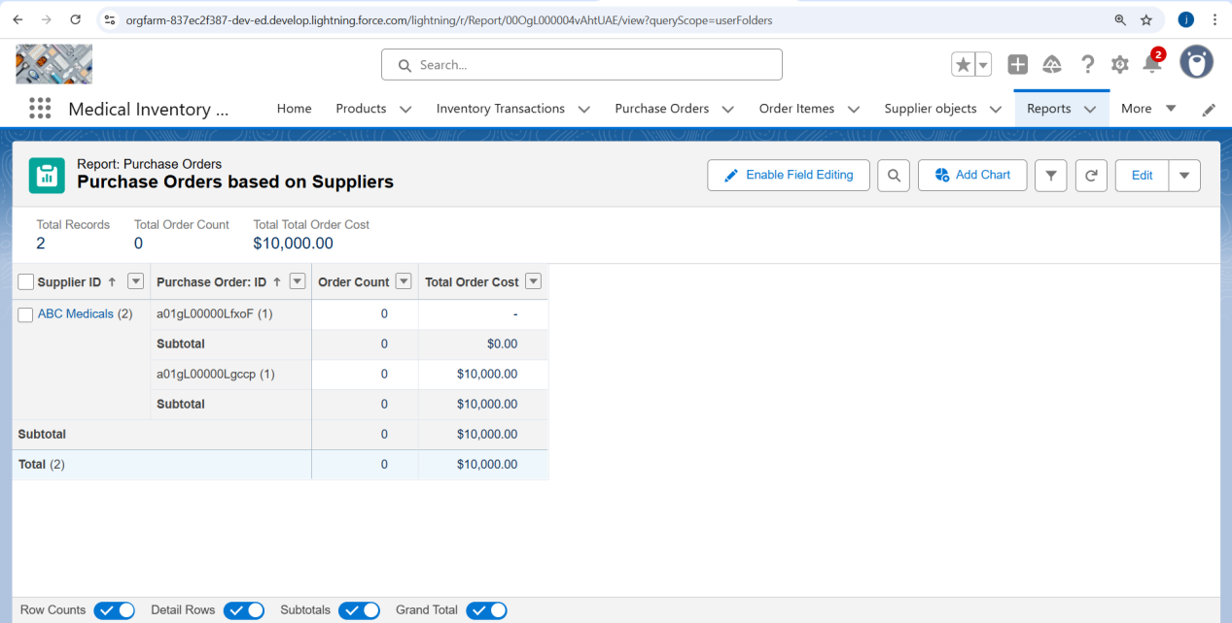

### **Activity 2: Create a Complete Purchase Details Report**

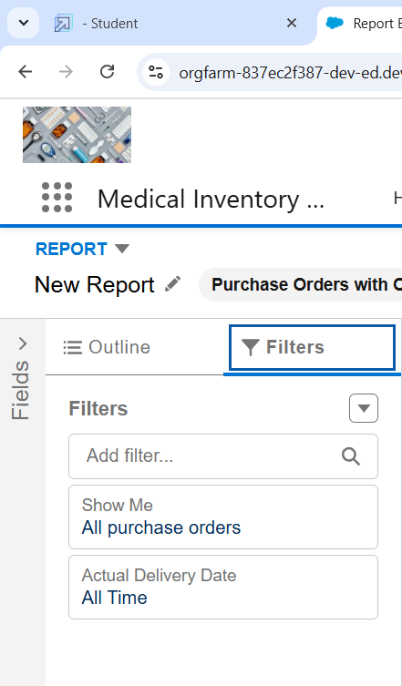

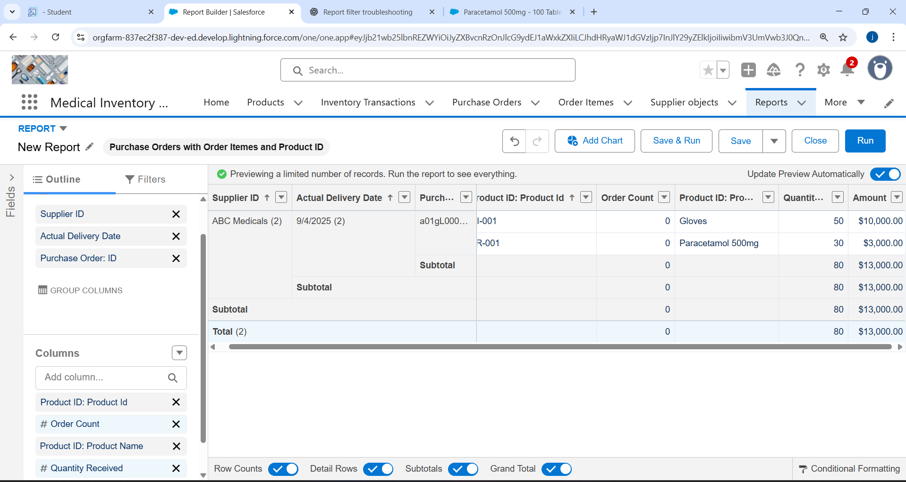

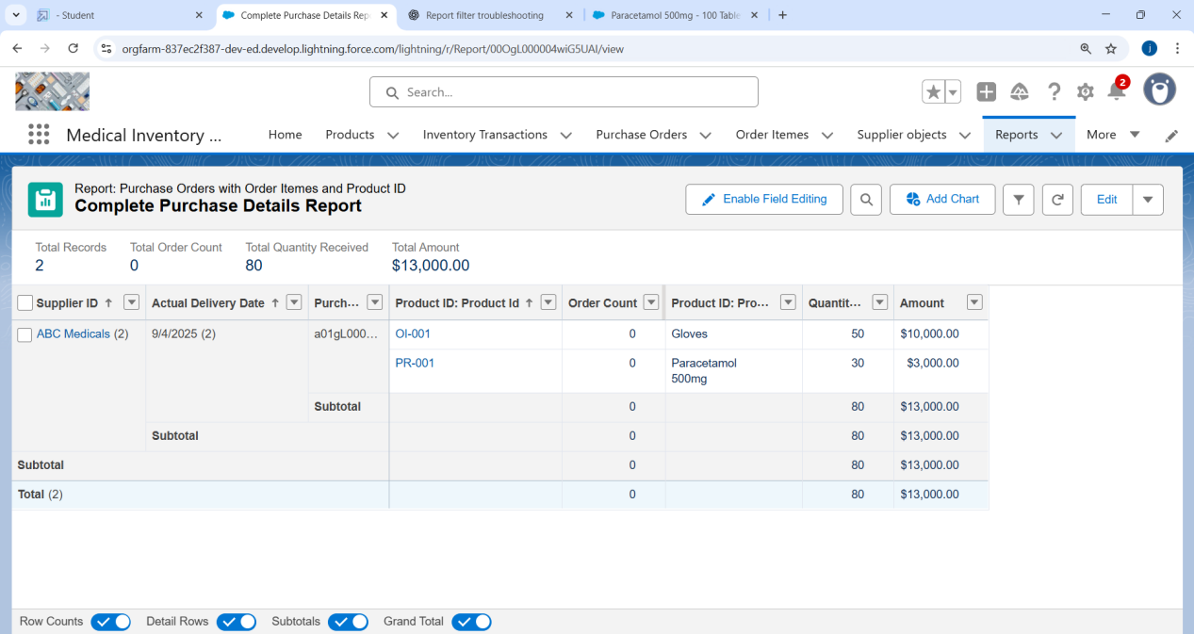**Milestone 16 - Dashboards**

**Activity 1: - Create Dashboard**

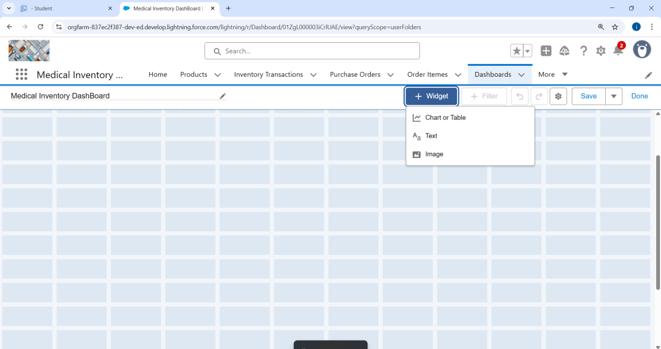

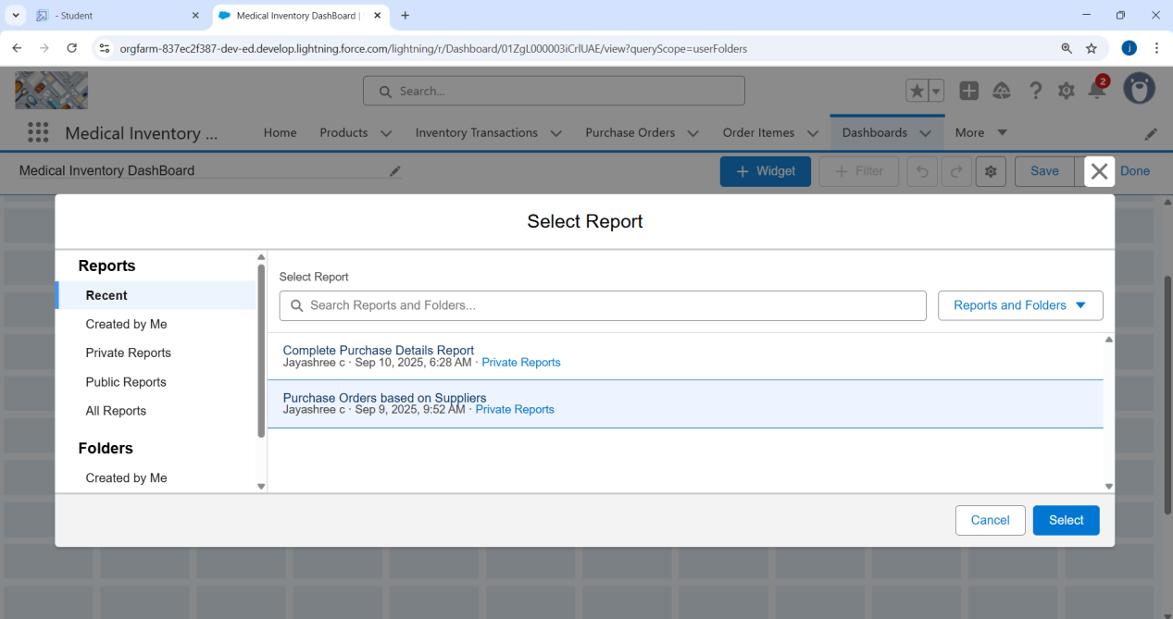

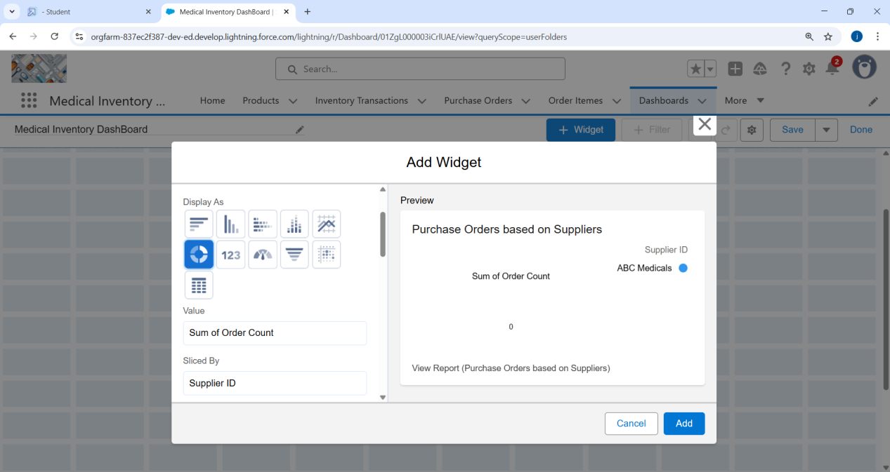

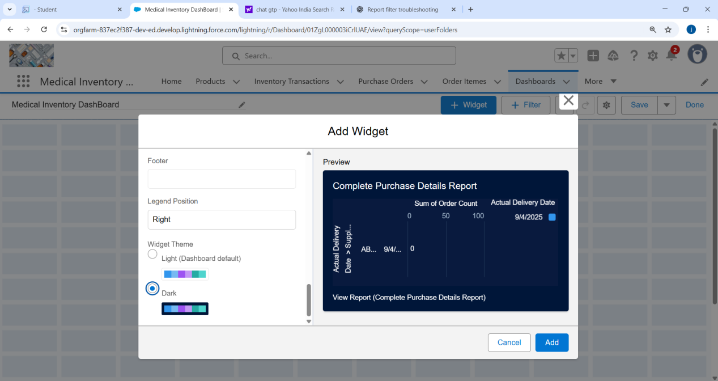**Activity 2: View Dashboard**

